ASSIGNMENT - 2

-- Create table Salesman

Create table Salesman(

salesman_id int primary key identity(101,1) not null,

s_name varchar(100) not null,

city varchar(50) not null,

commission decimal(3,2) not null

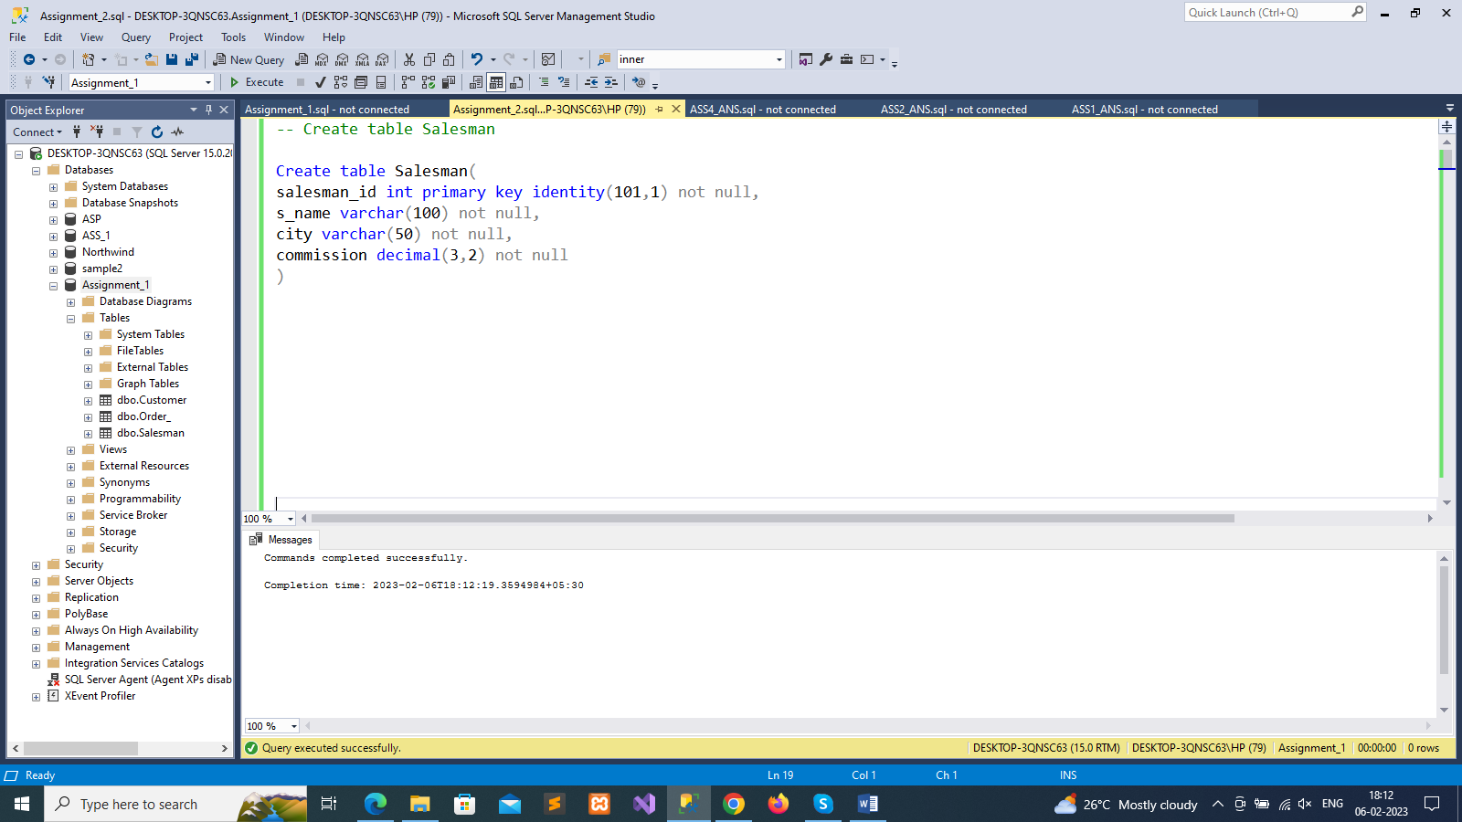

-- Create Table Customer

Create table Customer(

cust_id int primary key identity(101,1) not null,

c_name varchar(100) not null,

city varchar(100),

grade int,

salesman_id int

)

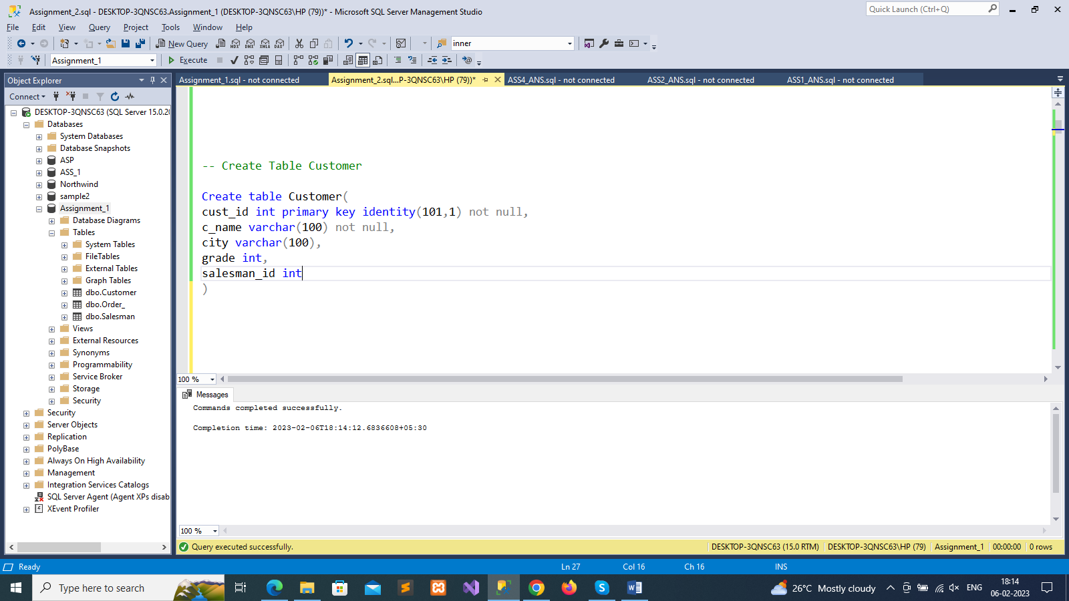

--Create Table Order_

Create table Order_(

ord_id int primary key identity(101,1) not null,

purch_amt decimal(10,2) not null,

ord_date date not null,

cust_id int,

salesman_id int

)

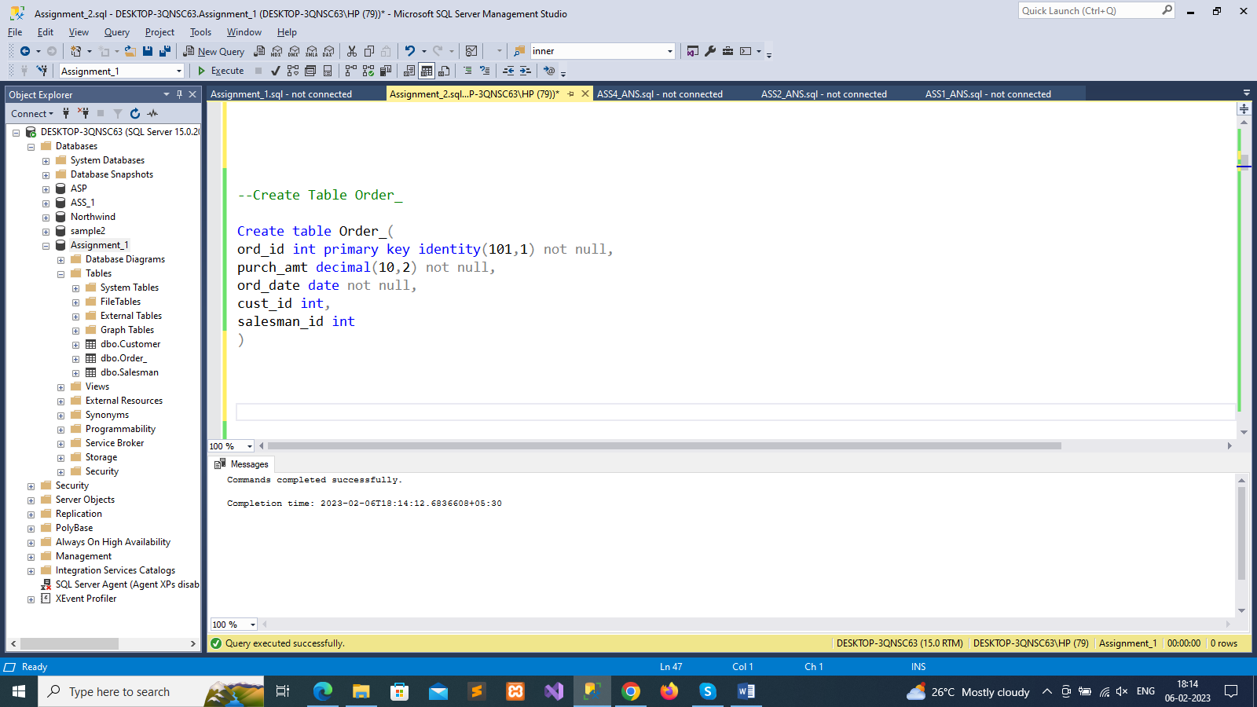

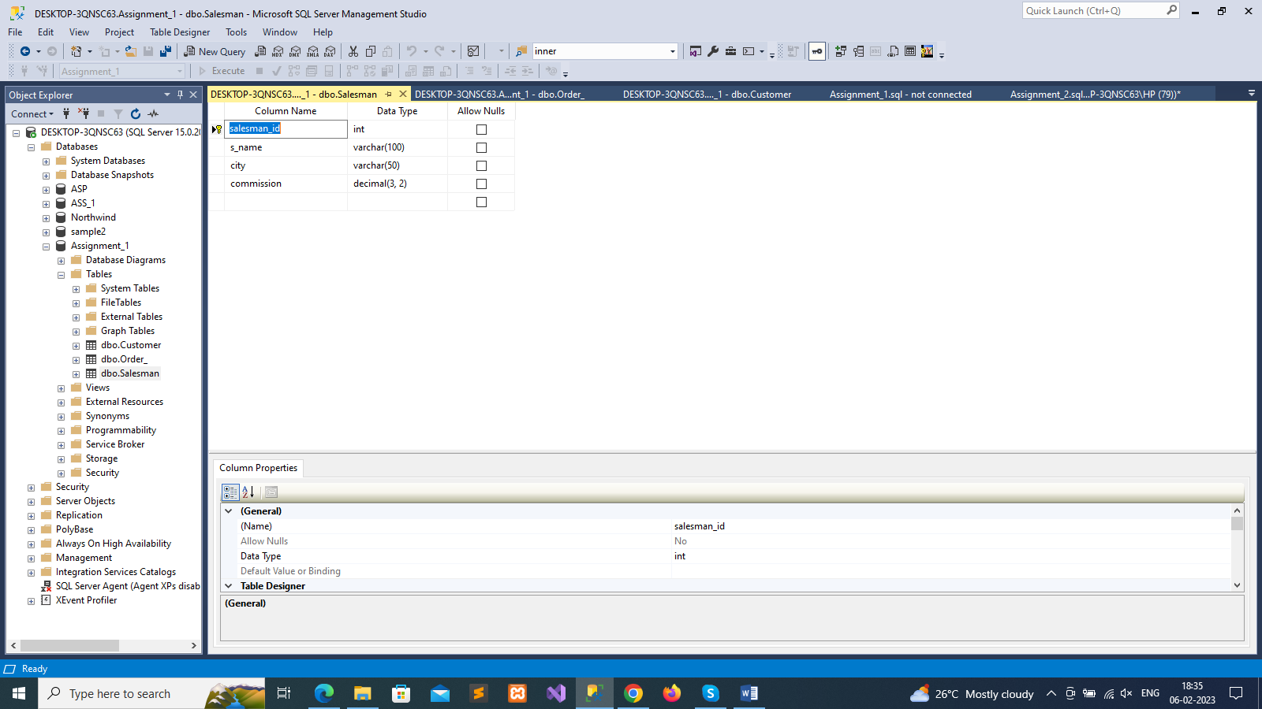

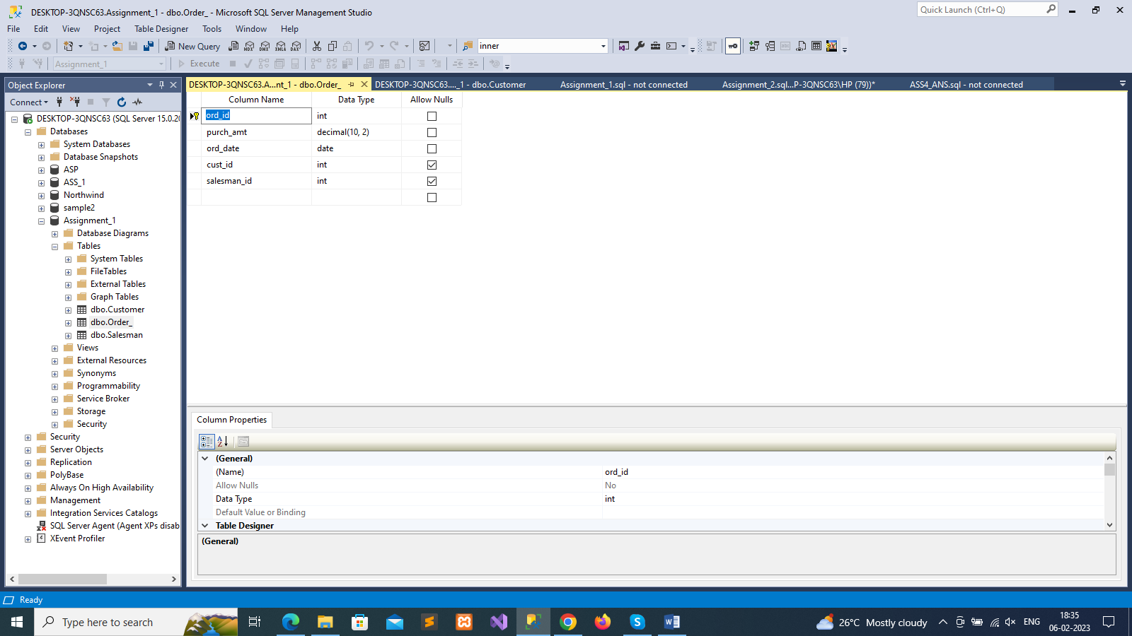

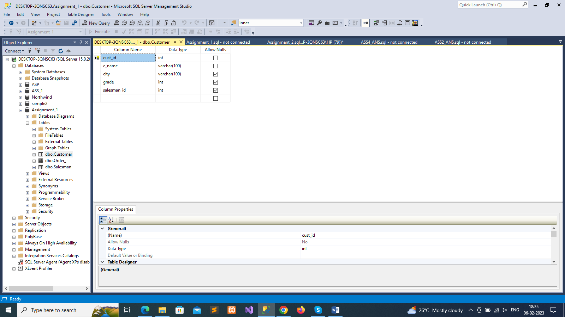

--insert data in salesman table

insert into Salesman values('Ram Patel','Ahmedabad','0.78'),

('Shreya Shah','Surat','0.12'),

('Jay Gohil','Anand','0.10'),

('Anand Ravat', 'Gandhinagar', '0.50'),

('Shrusti Deshmukh','Noyda','0.20'),

('Anu Patel','Kalol','0.15'),

('Mansi Acharya', 'Bhavnagar', '0.30'),

('Vyana jain', 'Rajkot','0.40'),

('Sahil Pithadiya','Rajkot','0.05'),

('Hiya Rajput','Surendranagar','0.10'),

('Jaini Gohel','Ahmedanad','0.20'),

('Juhi Patel','Surat','0.25'),

('Jiyansh Shah','Ahmedabad','0.70'),

('Janvi Patel','Jamnagar','0.11'),

('Binal Gohel','Gandhinagr','0.35'),

('Hardik Patel','Kalol','0.50')

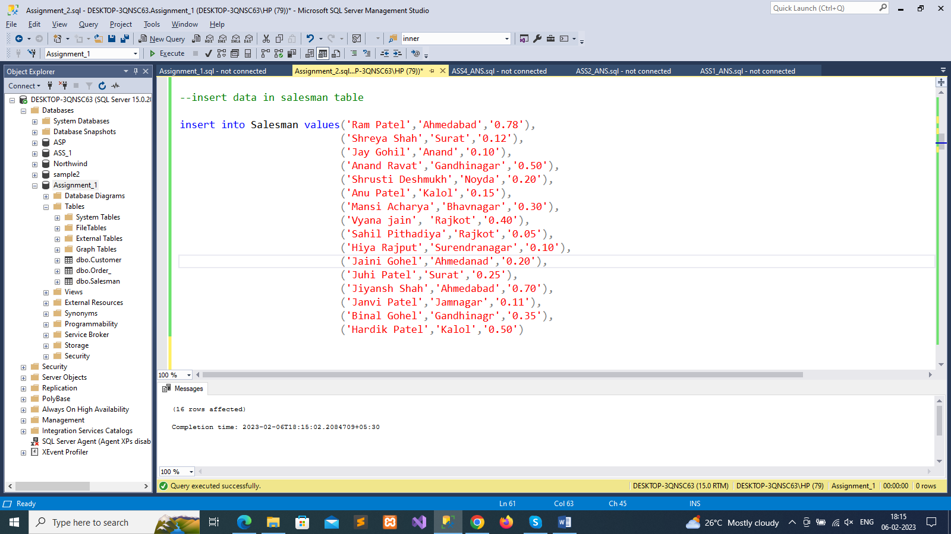

select * from Salesman

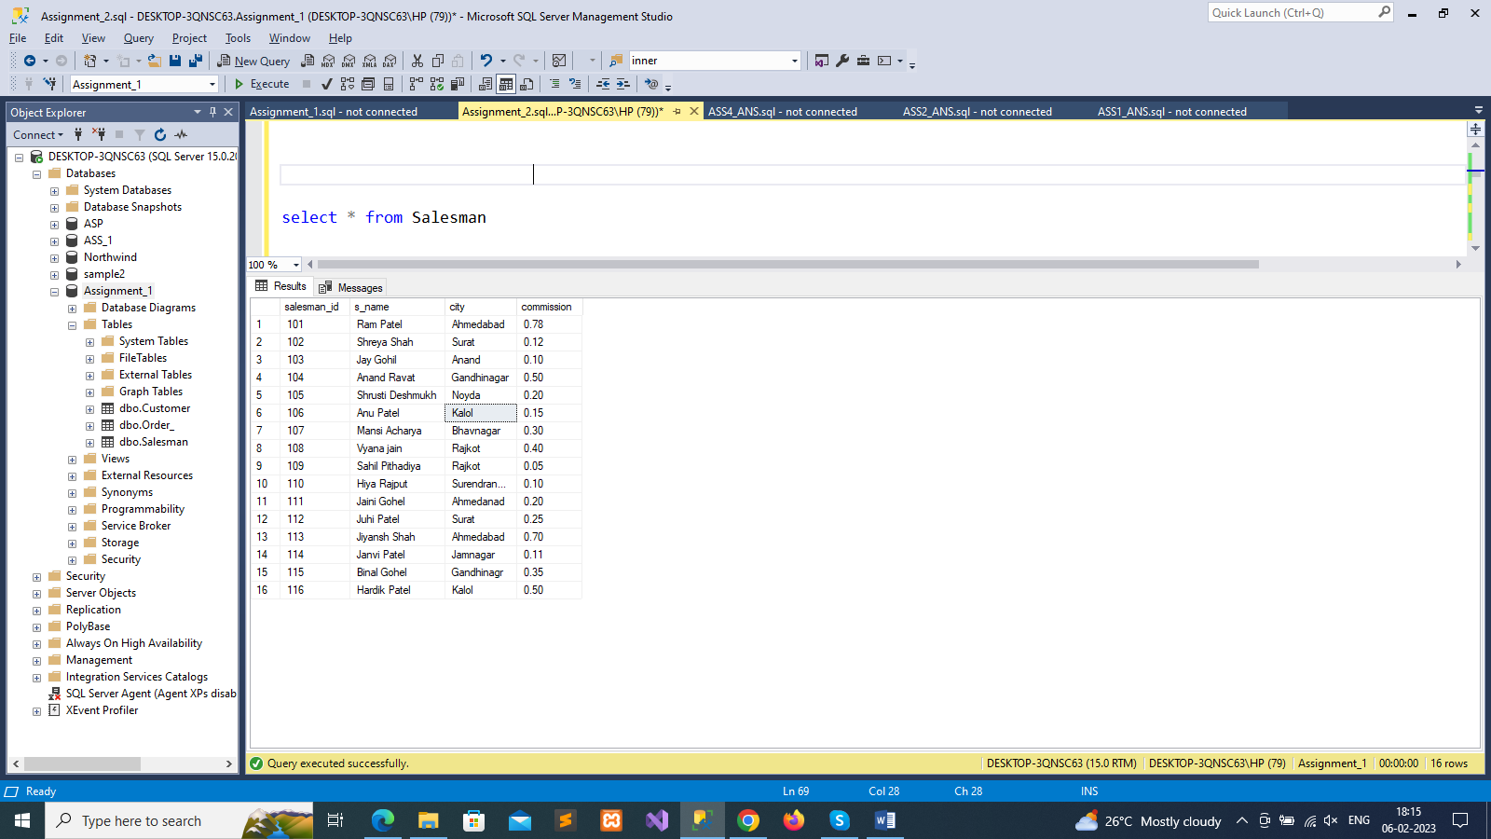

--insert data in customer table

insert into Customer values('Raagi Shah','Jamnagar',100,103),

('Hina Pithadiya','Ahmedabad',300,101),

('Priyal Vaghela','Anand',200,102),

('Siya Shah','Rajkot',null,105),

('Jiya Jain','Gandhigar',160,110),

('Vatsal Unkani', 'Bhavanagar', 700, 104),

('Janvi Patel','Rajkot',null,106),

('Jaini Shah','Rajkot',300,109),

('Shrusti Deshmukh','Noyda',130,108),

('Hetvi Patel','Gandhinagar',190,116),

('Hely Shah','Kalol',190,115),

('Priyansh Patel','Jamnagar',180,114),

('Manveer Patel','Rajkot',180,113),

('Hiyasha Patel','Jamnagar',180,112),

('Hiyasha Jain','Jamnagar',100,111)

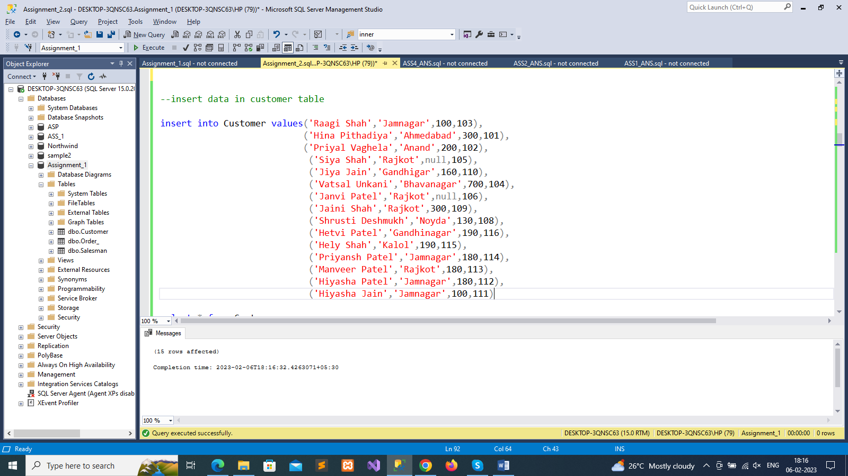

select * from Customer

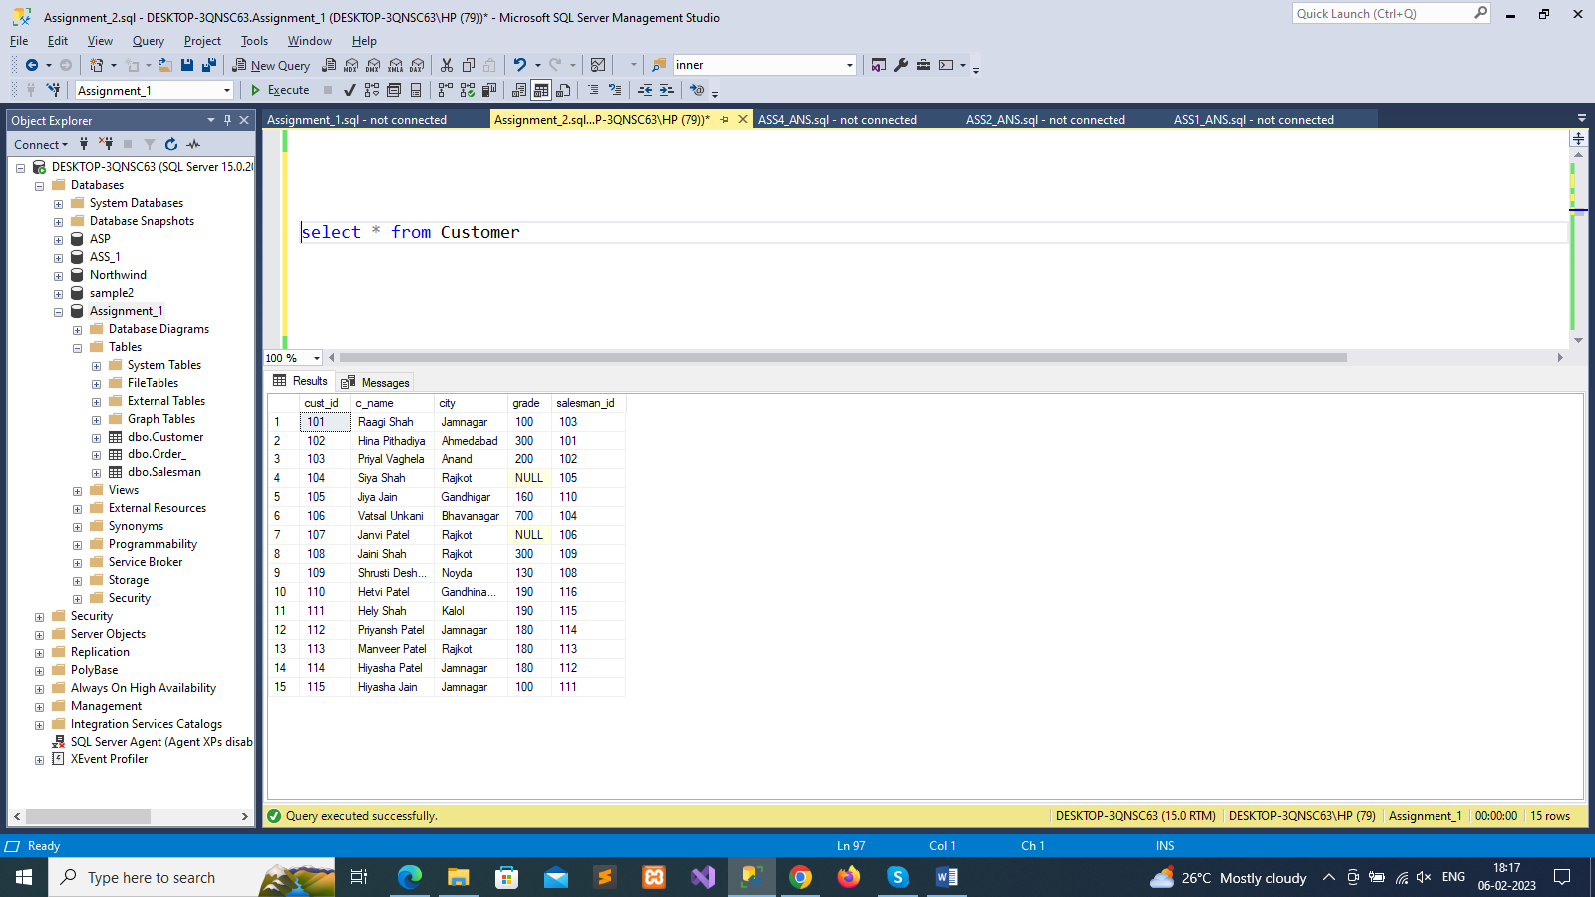

-- insert data in order table

insert into Order_ values(400,'2021-09-23',101,101),

(1500,'2020-07-17',103,102),

(1000,'2022-06-16',102,103),

(150.5,'2012-10-05',101 ,102),

(100.5, '2017-09-30',103 ,116),

(2100, '2019-08-11',109 ,115),

(78, '2022-09-10',107 ,114),

(2000, '2023-01-10',110 ,111),

(700, '2021-09-10',108 ,112),

(568, '2009-09-10',111 ,104),

(990, '2010-09-10',106 ,113),

(289, '2019-09-10',112 ,105),

(350, '2020-09-10',105 ,110),

(2100, '2000-09-10',113 ,109),

(2300, '2015-09-10',103 ,106),

(230, '2017-09-10',114 ,107),

(210, '2015-09-10',103 ,108),

(200, '2014-09-10',115 ,102)

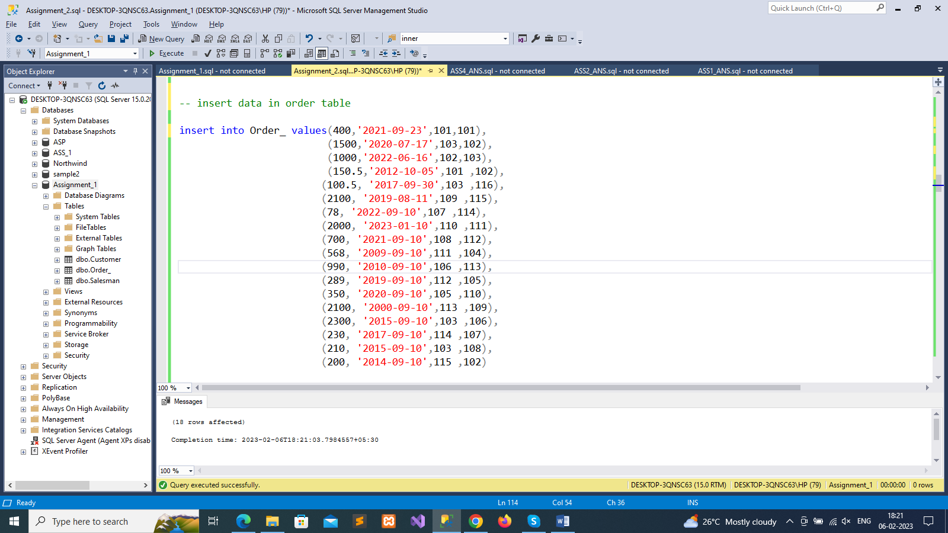

select * from Order_

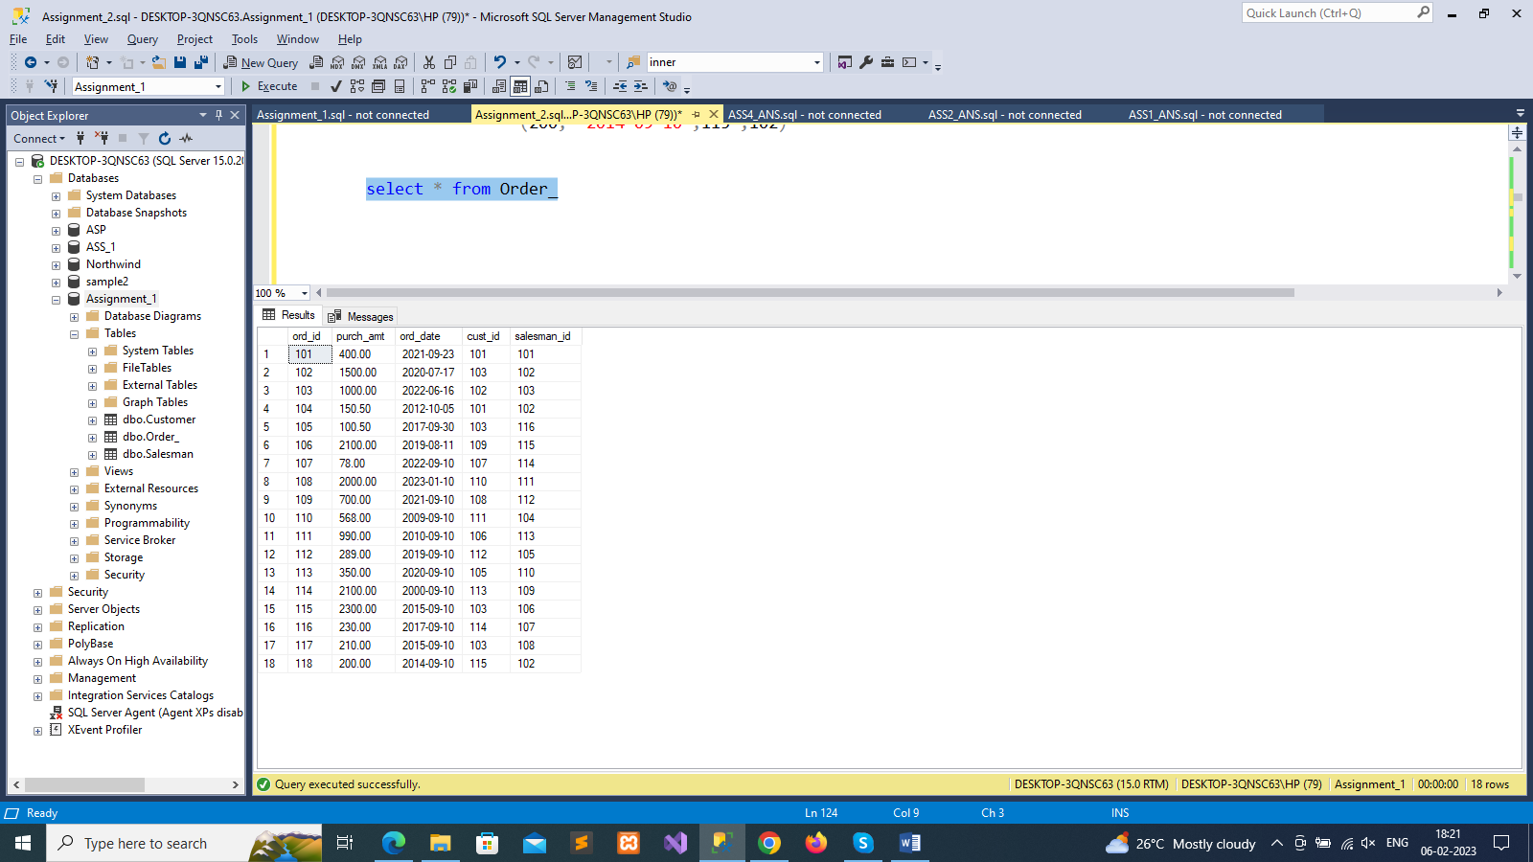

-- 1. write a SQL query to find the salesperson and customer who reside in the same city. Return Salesman, cust_name and city

select s_name as Salesman,c_name as Customer_name,Customer.city

from Salesman, Customer

where Salesman.city=Customer.city

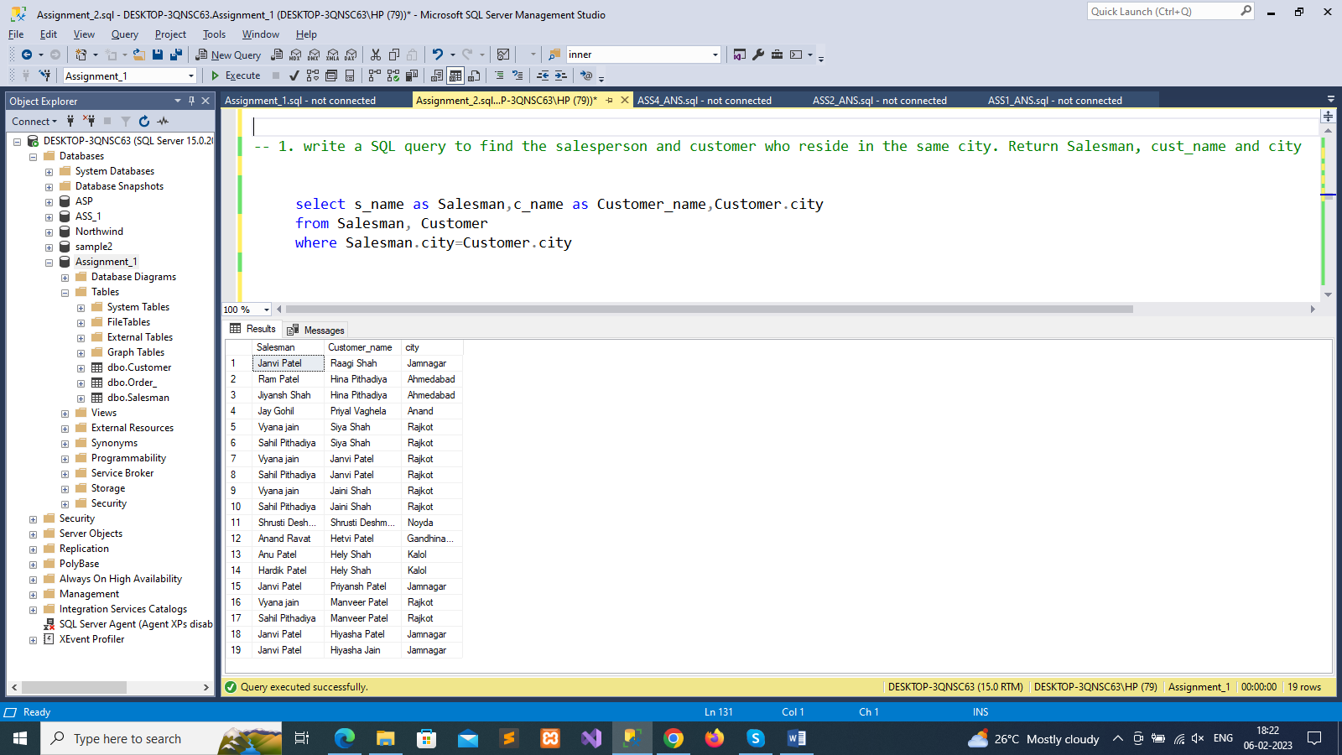

--2. write a SQL query to find those orders where the order amount exists between 500 and 2000.

--Return ord_no, purch_amt, cust_name, city

select o.ord_id as order_no,o.purch_amt,c.c_name as Customer_name,c.city

from Order_ o

inner join Customer c on c.cust_id=o.ord_id

where o.purch_amt between 500 and 2000

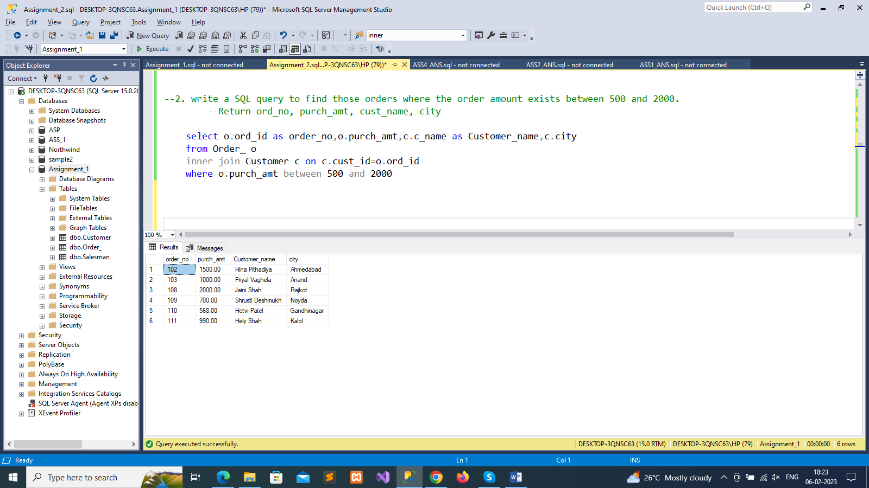

-- 3. write a SQL query to find the salesperson(s) and the customer(s) he represents.

--Return Customer Name, city, Salesman, commission

select c.c_name as Customer_name,c.city,s.s_name as Salesman,s.commission

from Customer c

inner join Salesman s on s.salesman_id=c.salesman_id

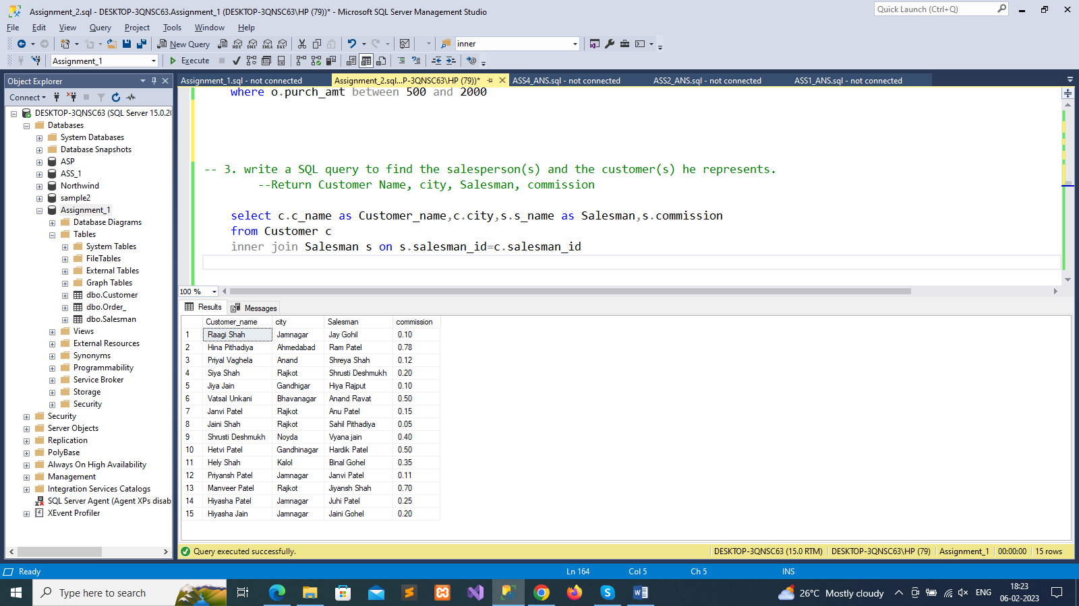

-- 4. write a SQL query to find salespeople who received commissions of more than 12 percent from the company.

--Return Customer Name, customer city, Salesman, commission.

select c.c_name as customer_name, c.city,s.s_name as salesman,s.commission

from Customer c

inner join Salesman s on s.salesman_id=c.salesman_id

where s.commission > 0.12

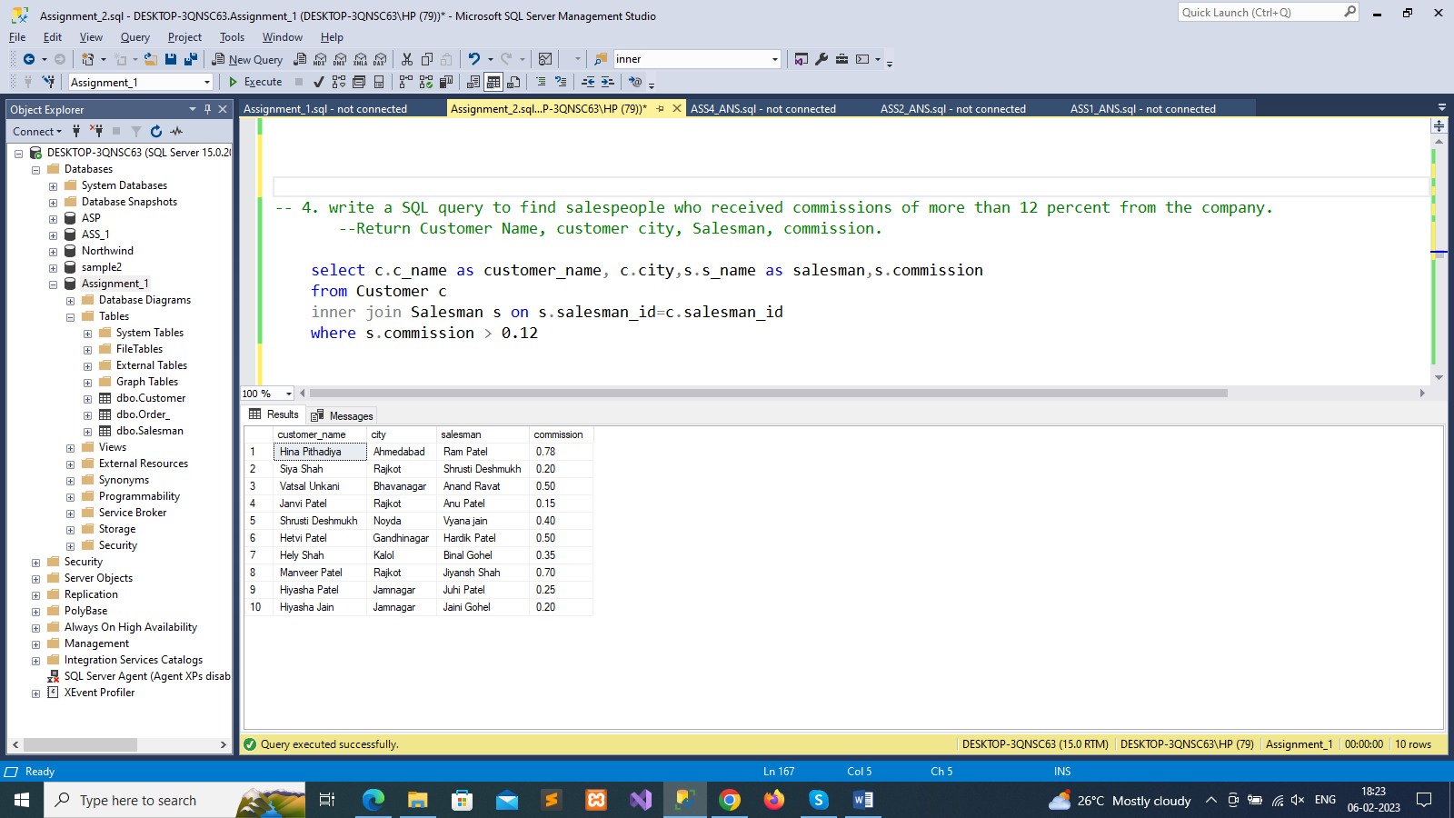

--5. write a SQL query to locate those salespeople who do not live in the same city where their customers live and

--have received a commission of more than 12% from the company. Return Customer Name, customer city, Salesman,

--salesman city, commission

select c.c_name as customer_name, c.city,s.s_name as salesman, s.city, s.commission

from Customer c

inner join Salesman s on s.salesman_id = c.salesman_id

where s.commission >.12 and c.city <> s.city

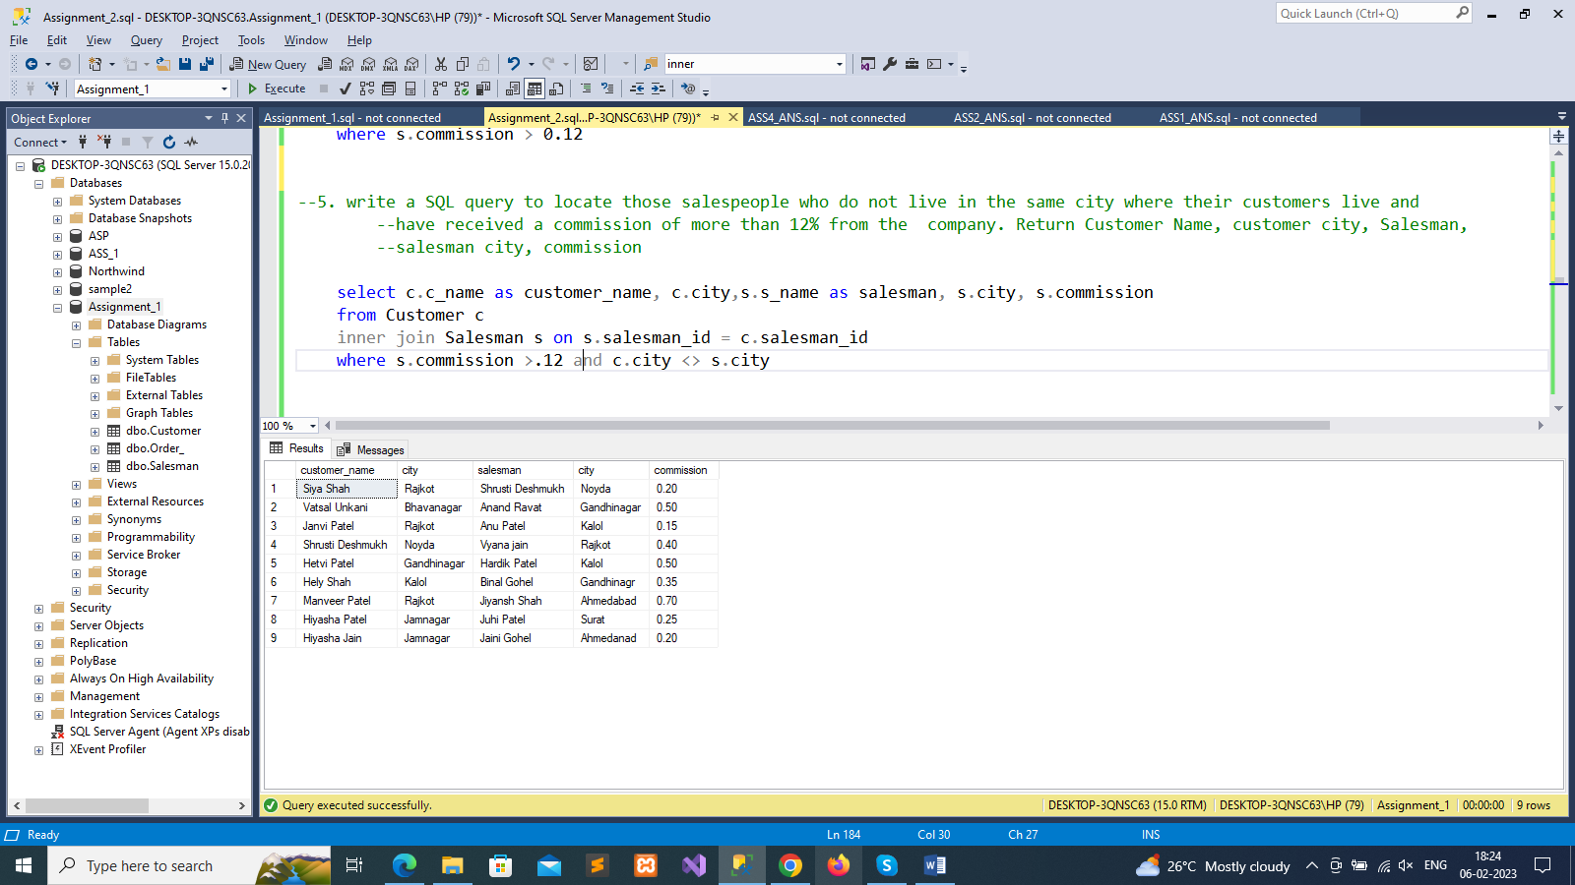

-6. write a SQL query to find the details of an order. Return ord_no, ord_date, purch_amt, Customer Name, grade, Salesman,

--commission

select o.ord_id as order_no, o.ord_date, o.purch_amt,c.c_name as customer_name,c.grade,s.s_name as salesman,s.commission

from Order_ o

inner join Customer c on o.cust_id=c.cust_id

inner join Salesman s on o.salesman_id= s.salesman_id

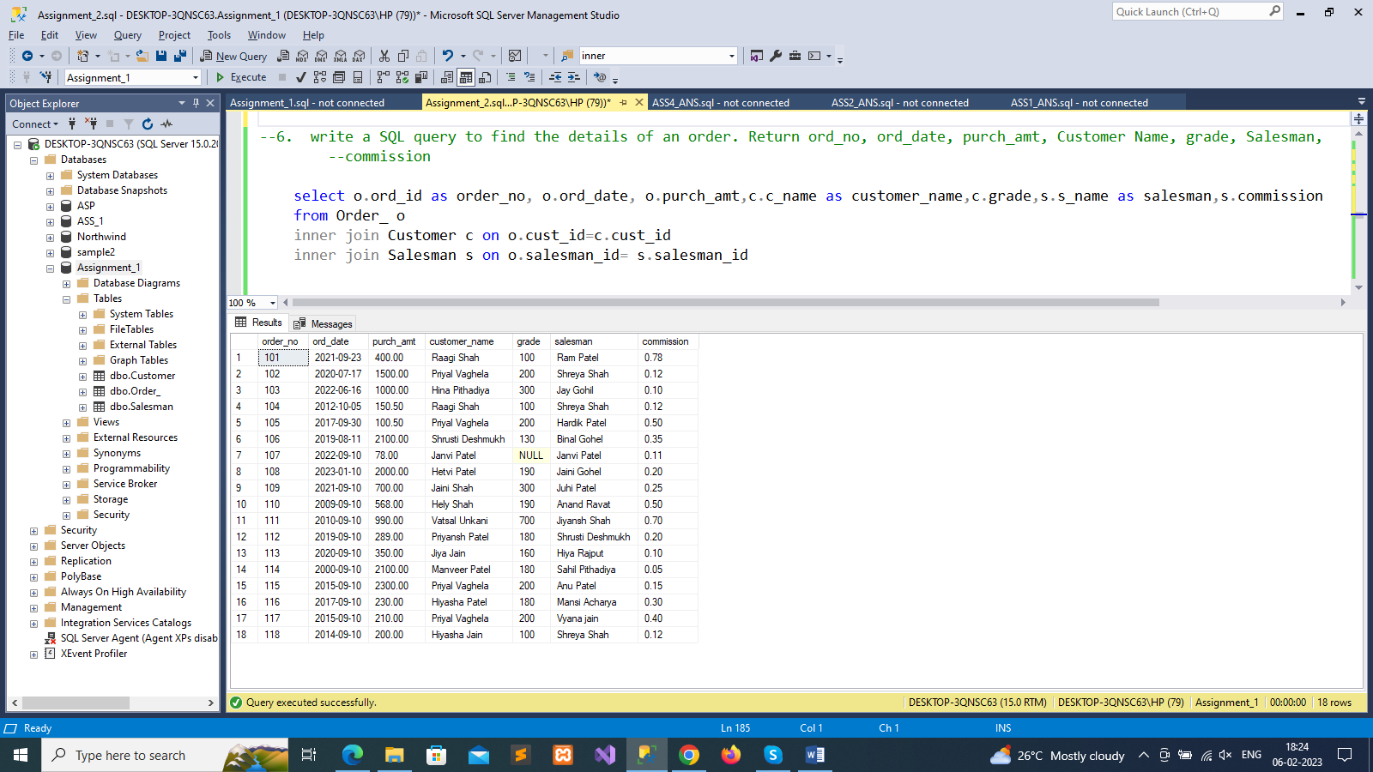

--7. Write a SQL statement to join the tables salesman, customer and orders so that the same column of each table appears

--once and only the relational rows are returned.

select *

from Order_ o

full outer join Customer c on o.cust_id=c.cust_id

full outer join Salesman s on o.salesman_id=s.salesman_id

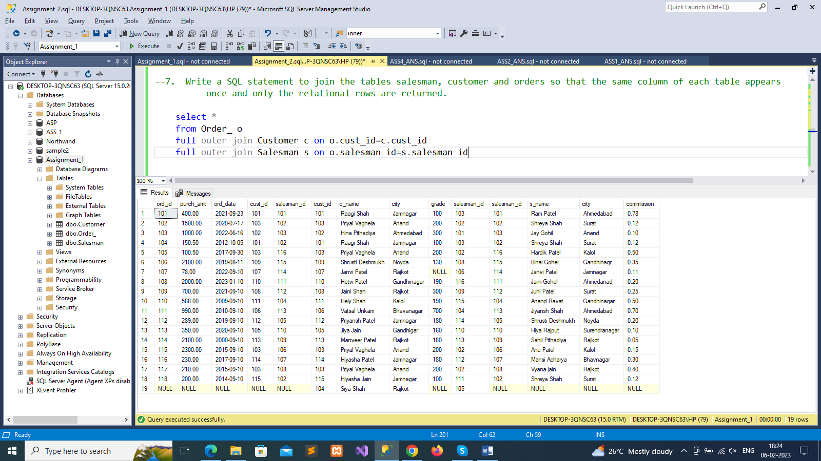

--8. write a SQL query to display the customer name, customer city, grade, salesman, salesman city.

--The results should be sorted by ascending customer_id.

select c.c_name as customer_name,c.city,c.grade,s.s_name as salesman

from Customer c

inner join Salesman s on s.salesman_id=c.cust_id

order by c.cust_id asc

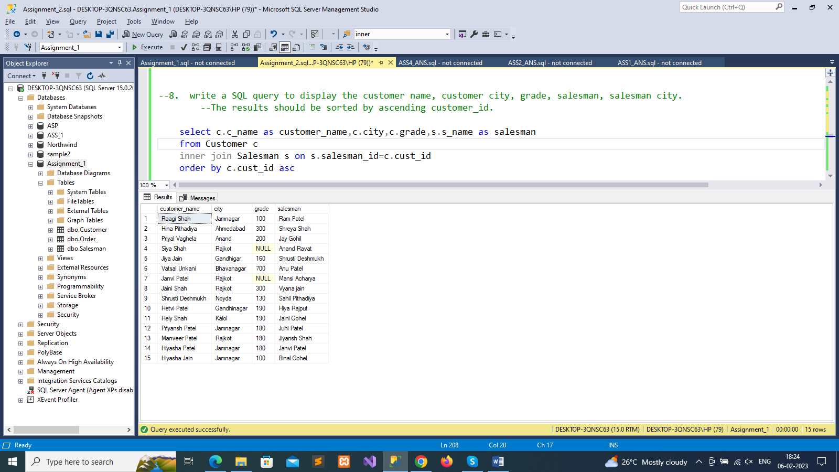

--9 write a SQL query to find those customers with a grade less than 300. Return cust_name, customer city, grade, Salesman,

--salesman city. The result should be ordered by ascending customer_id.

select c.c_name as customer_name,c.city,c.grade,s.s_name as salesman,s.city

from Customer c

left outer join Salesman s on s.salesman_id=c.salesman_id

where c.grade<300

order by c.cust_id asc

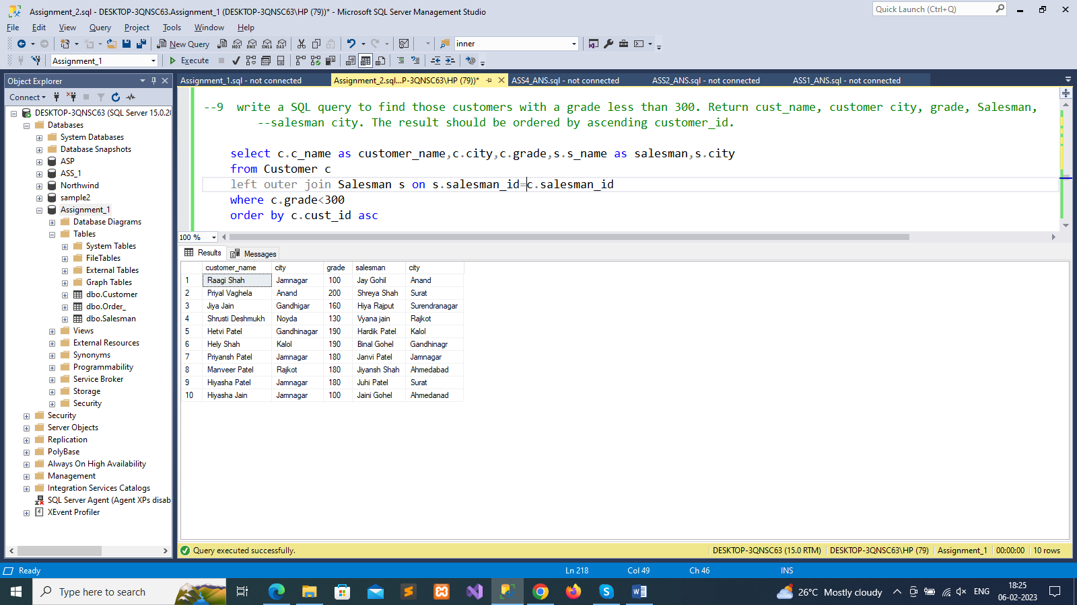

--10 Write a SQL statement to make a report with customer name, city, order number, order date, and order amount

--in ascending order according to the order date to determine whether any of the existing customers have placed an

--order or not

select c.c_name,c.city,o.ord_id,o.ord_date,o.purch_amt

from Customer c

left outer join Order_ o on c.cust_id=o.cust_id

order by o.ord_date asc

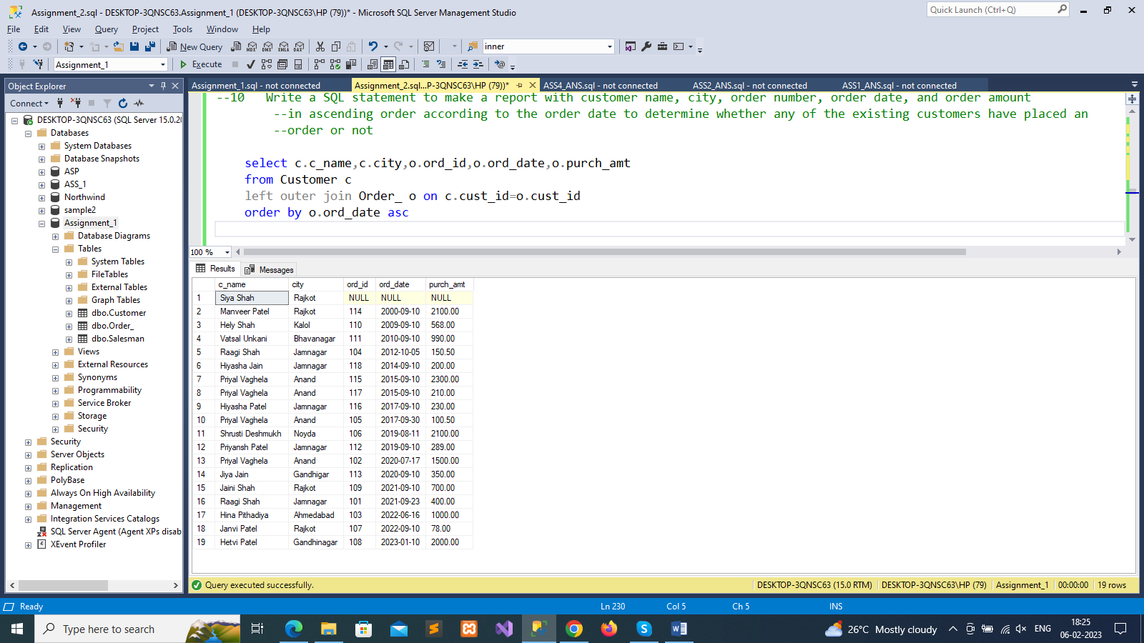

--11 Write a SQL statement to generate a report with customer name, city, order number, order date, order amount,

--salesperson name, and commission to determine if any of the existing customers have not placed orders or if they

--have placed orders through their salesman or by themselves

select c.c_name,c.city,o.ord_id as order_number,o.ord_date,o.purch_amt as order_amount,s.s_name as salesperson_name,s.commission

from Customer c

left outer join Order_ o on c.cust_id=o.cust_id

left outer join Salesman s on s.salesman_id=o.salesman_id

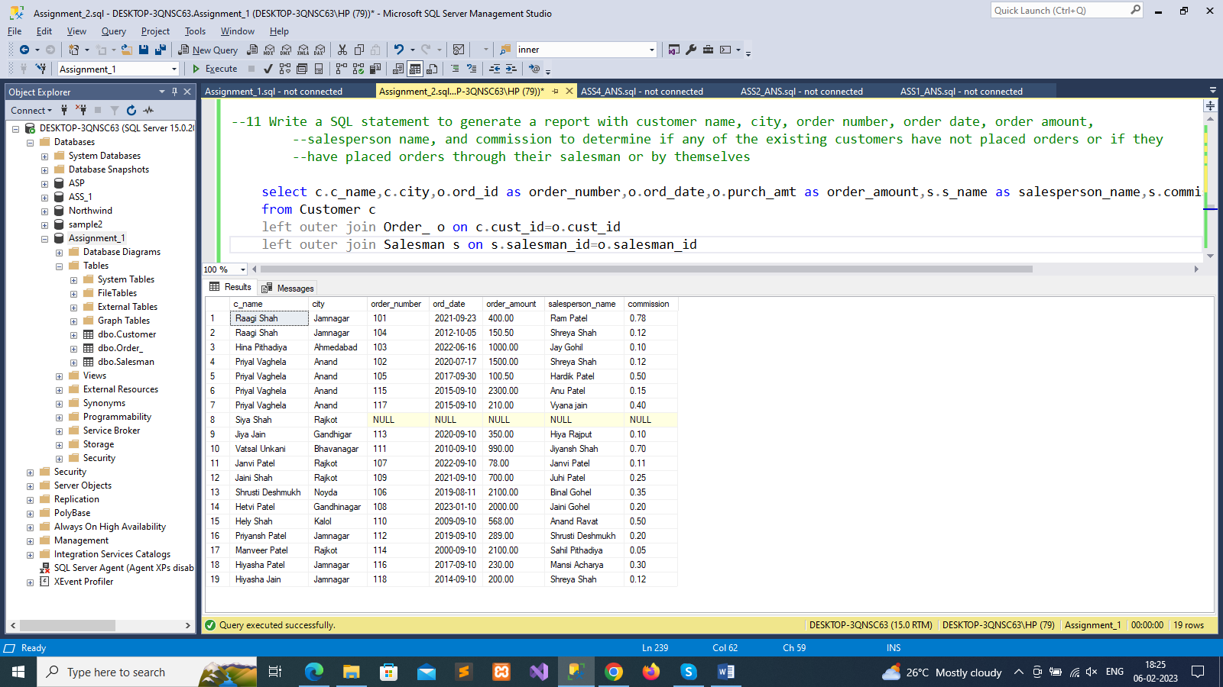

--12. Write a SQL statement to generate a list in ascending order of salespersons who work either for one or more customers

--or have not yet joined any of the customers

select c.c_name,c.city,c.grade,s.s_name,s.city

from Customer c

right outer join Salesman s on s.salesman_id = c.salesman_id

order by s.salesman_id;

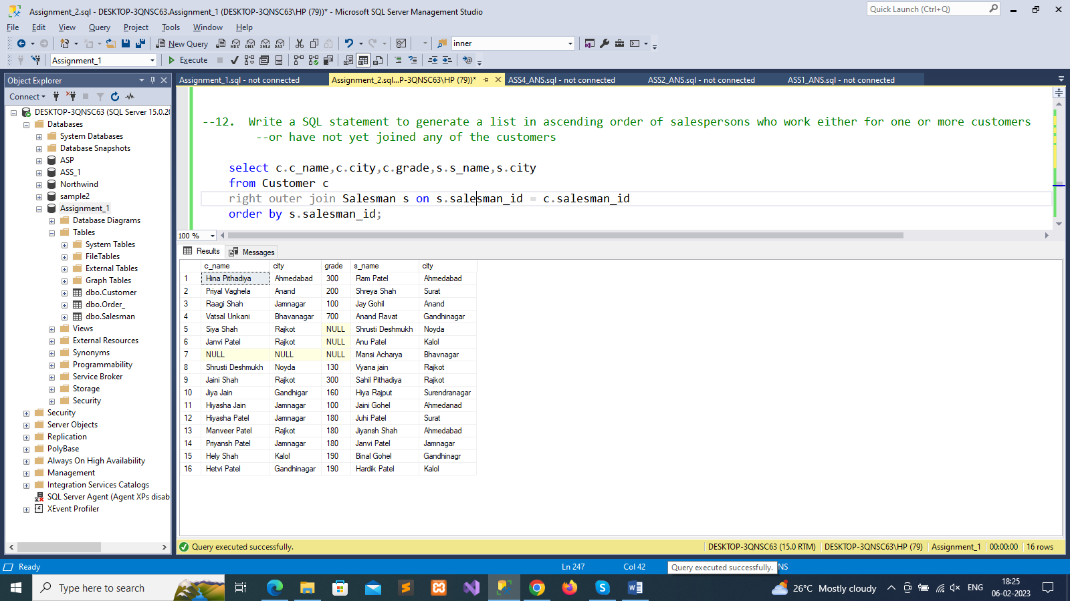

--13. write a SQL query to list all salespersons along with customer name, city, grade, order number, date, and amount.

select c.c_name,c.city,c.grade,o.ord_id,o.ord_date,o.purch_amt

from Customer c

right outer join Salesman s on s.salesman_id=c.salesman_id

right outer join Order_ o on c.cust_id=o.cust_id

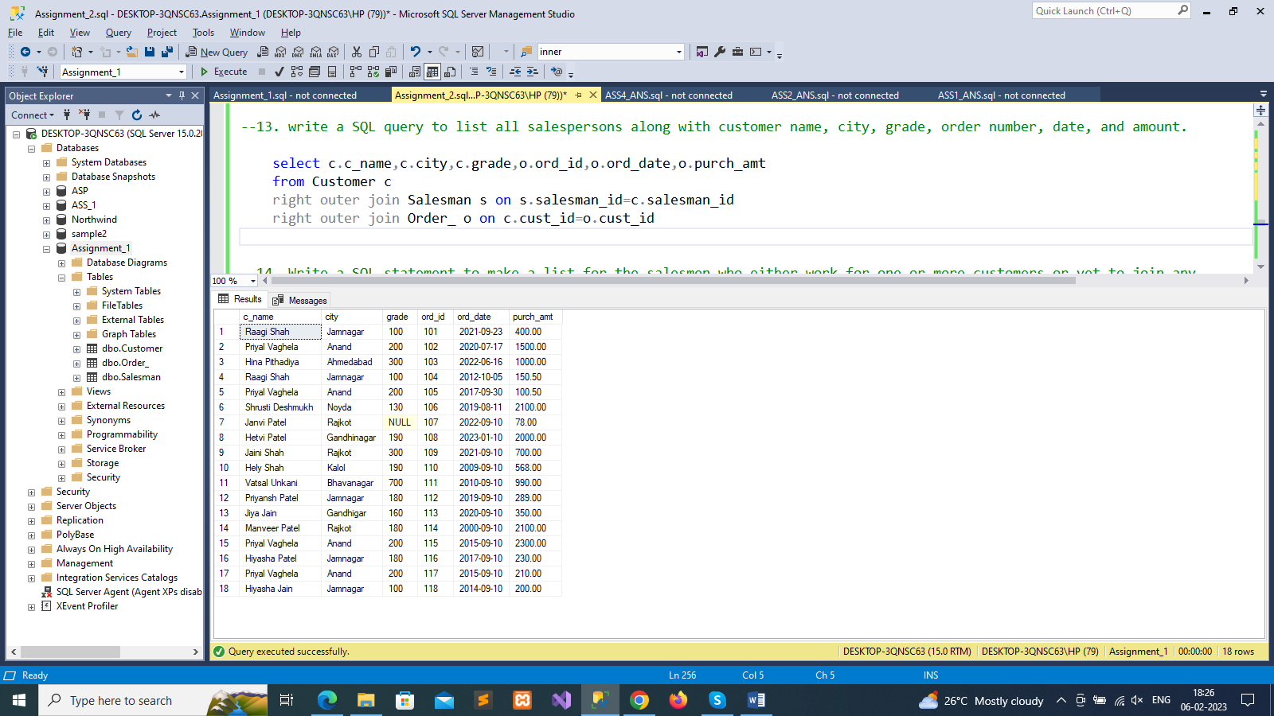

--14. Write a SQL statement to make a list for the salesmen who either work for one or more customers or yet to join any

--of the customers. The customer may have placed, either one or more orders on or above order amount 2000 and must

--have a grade, or he may not have placed any order to the associated supplier.

select c.c_name,c.city,c.grade,s.s_name,o.ord_id,o.ord_date,o.purch_amt

from Customer c

right outer join Salesman s on s.salesman_id=c.salesman_id

left outer join Order_ o on o.cust_id =c.cust_id

where o.purch_amt>=2000

and c.grade is not null;

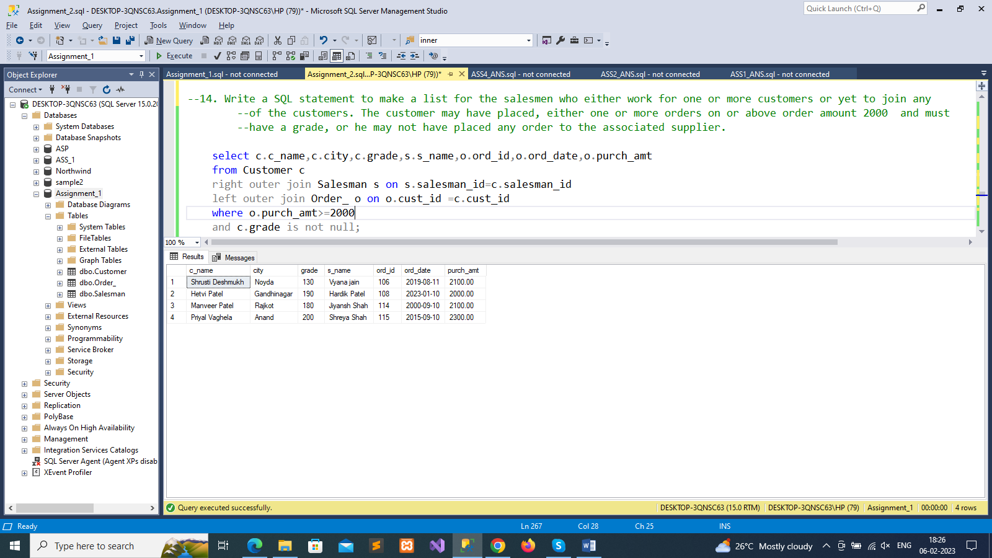

--15. Write a SQL statement to generate a list of all the salesmen who either work for one

--or more customers or have yet to join any of them. The customer may have placed

--one or more orders at or above order amount 2000, and must have a grade, or he

--may not have placed any orders to the associated supplier .

select c.c_name, c.city, c.grade, s.s_name, o.ord_id, o.ord_date, o.purch_amt

from Customer c

right outer join Salesman s on s.salesman_id=c.salesman_id

left outer join Order_ o on o.cust_id =c.cust_id

where o.purch_amt>=2000

and c.grade is not null;

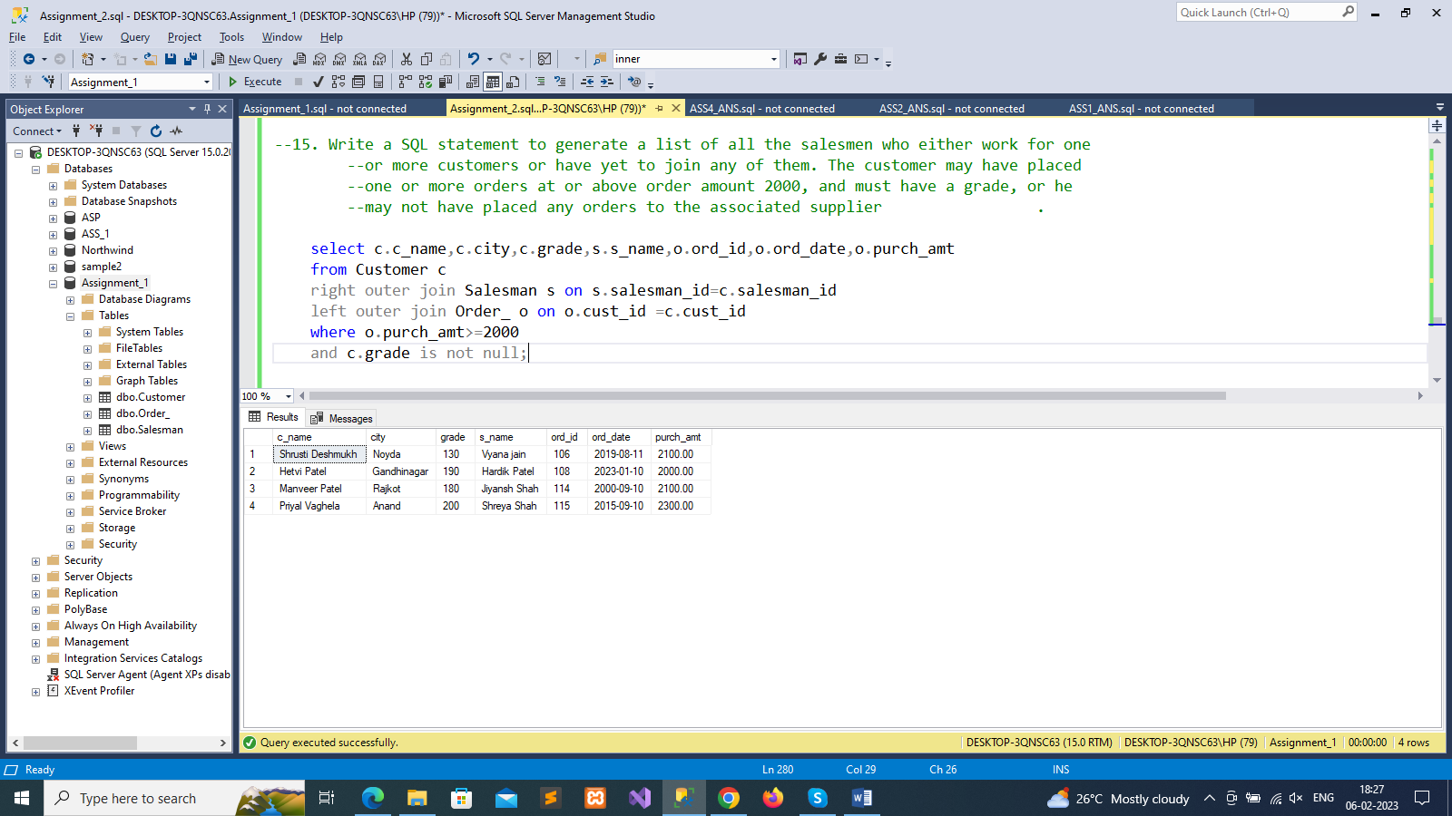

--16. Write a SQL statement to generate a report with the customer name, city, order no. order date, purchase amount for only

--those customers on the list who must have a grade and placed one or more orders or which order(s) have been placed by

--the customer who neither is on the list nor has a grade.

select c.c_name,c.city,o.ord_id,o.ord_date,o.purch_amt

from Customer c

full outer join Order_ o on c.cust_id=o.cust_id

where c.grade is not null;

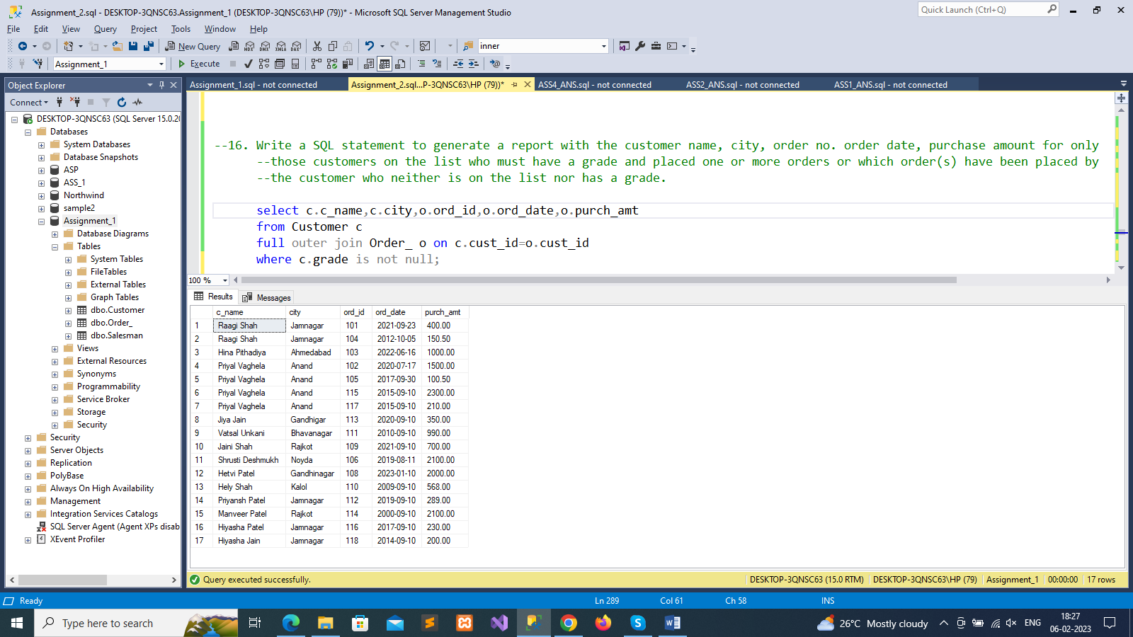

--17. Write a SQL query to combine each row of the salesman table with each row of the customer table

select *

from Customer

cross join Salesman

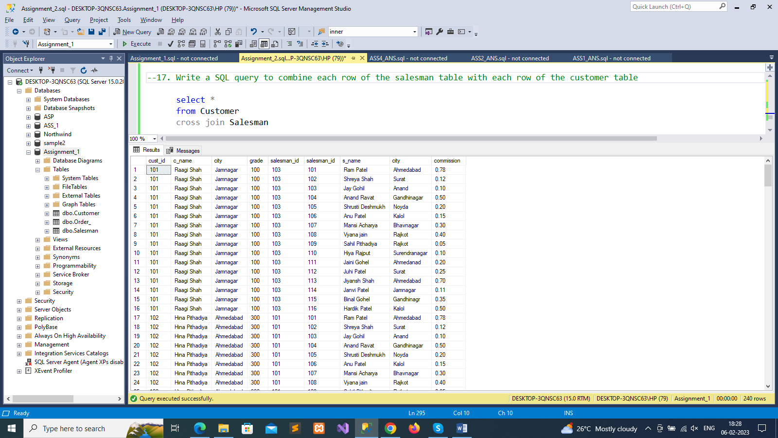

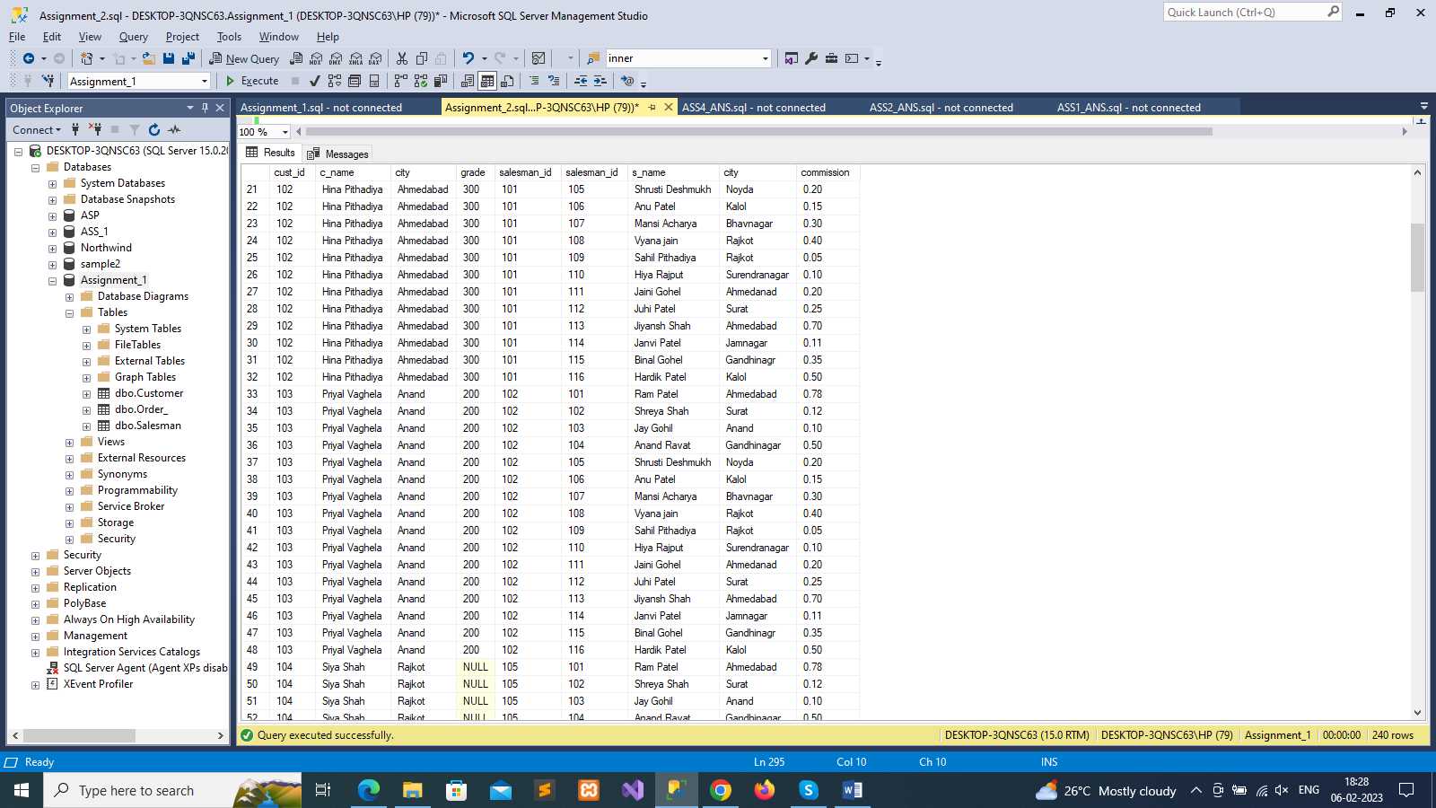

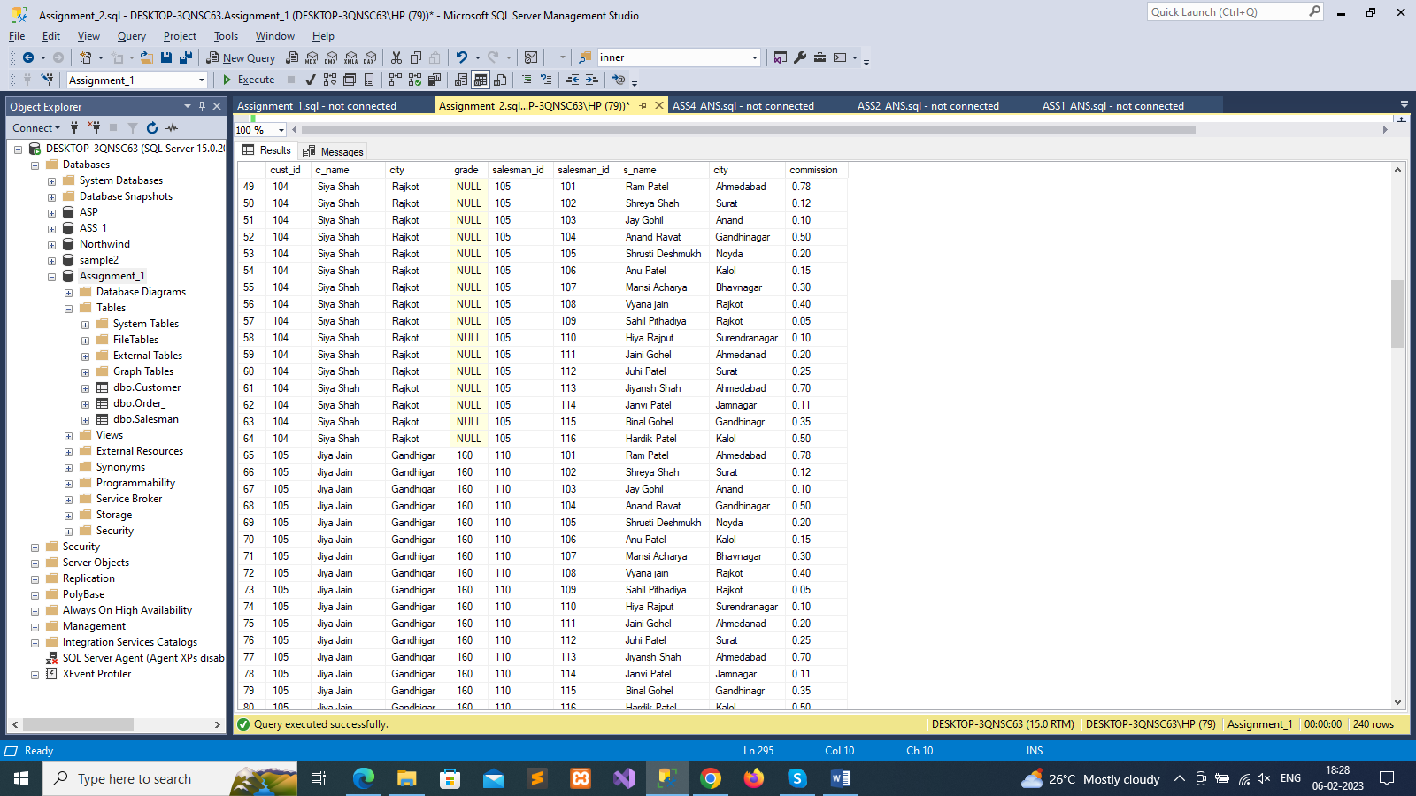

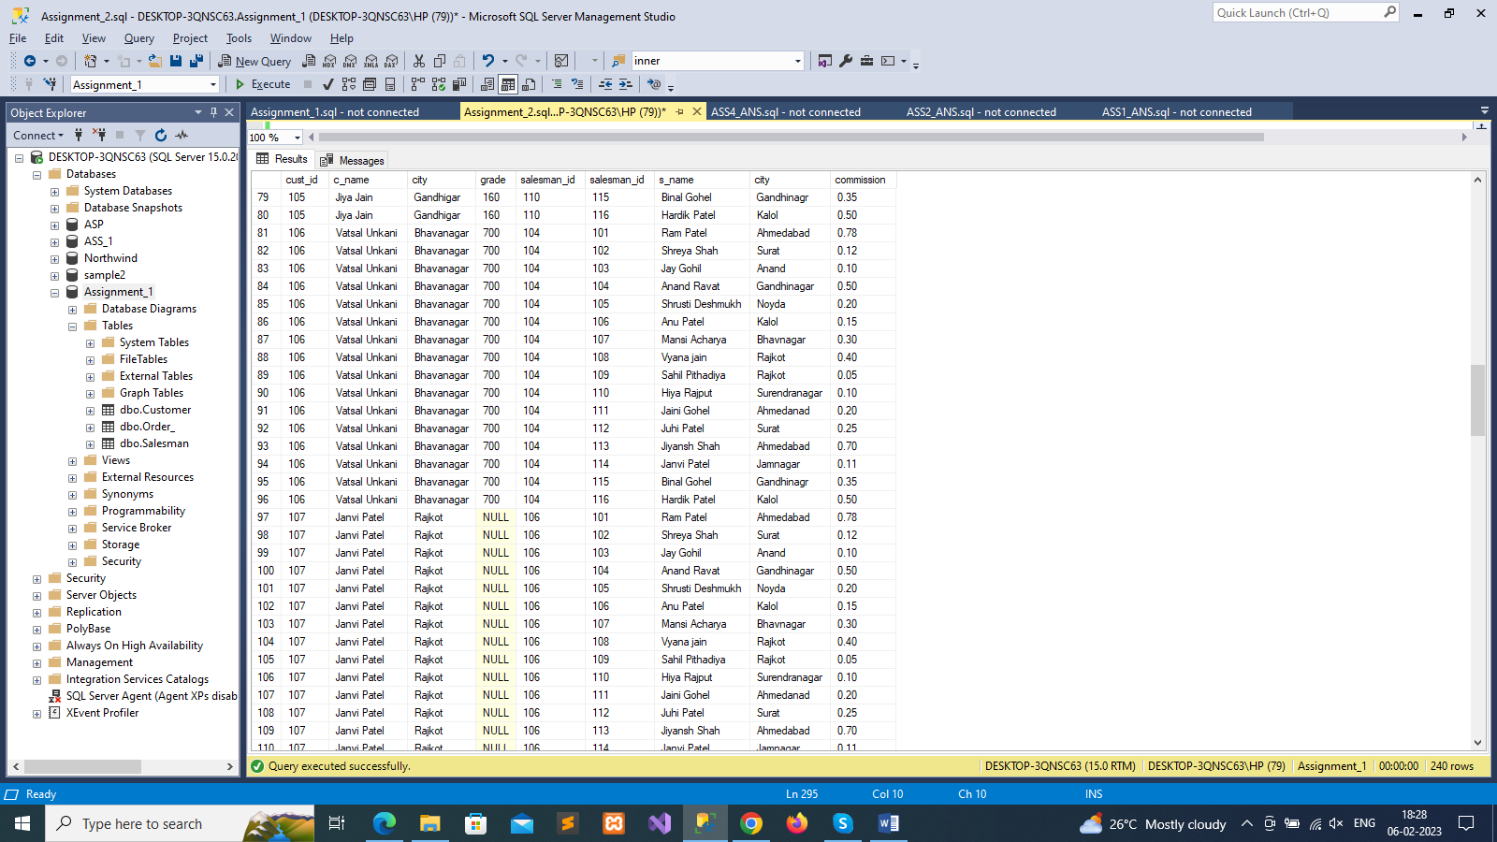

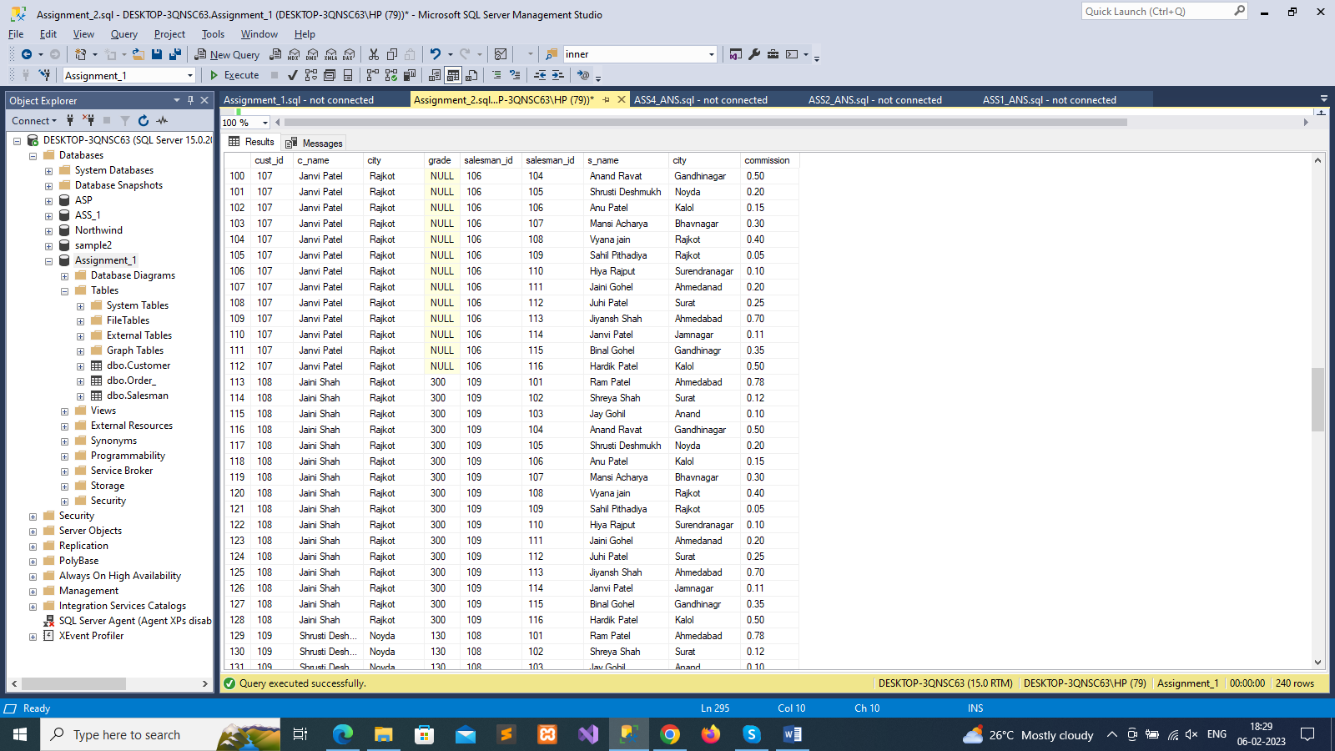

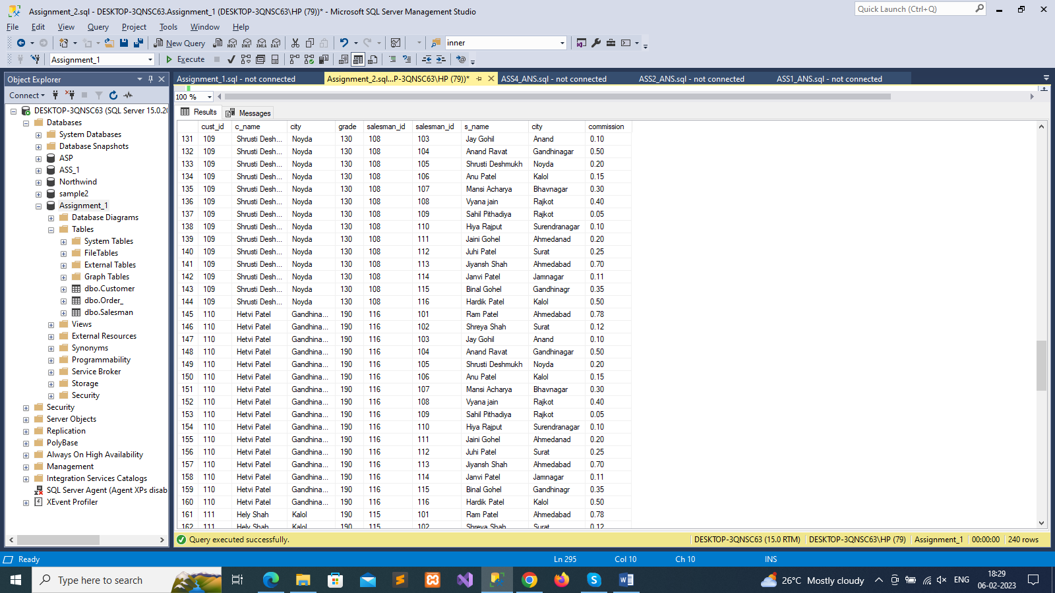

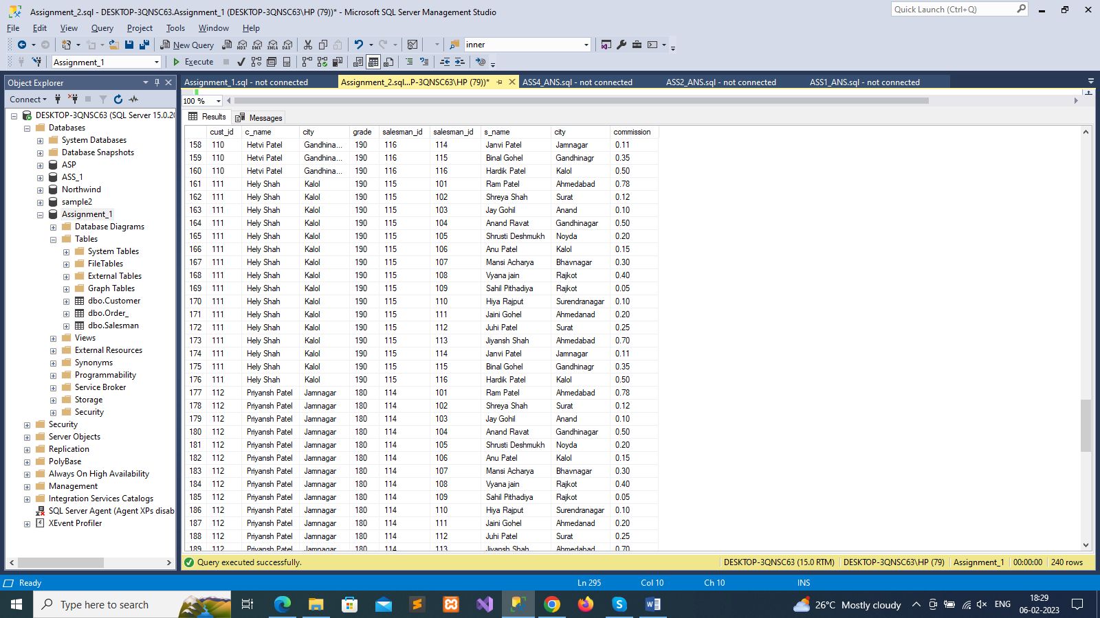

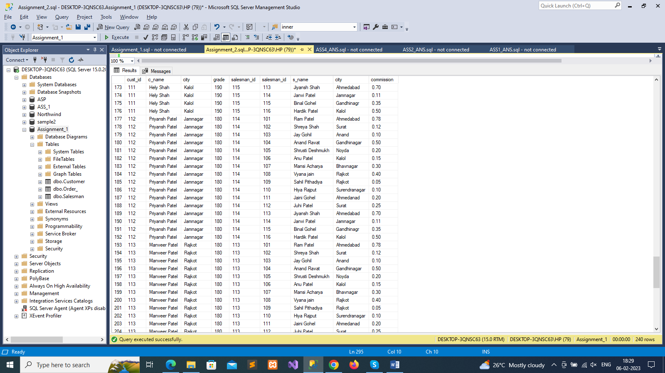

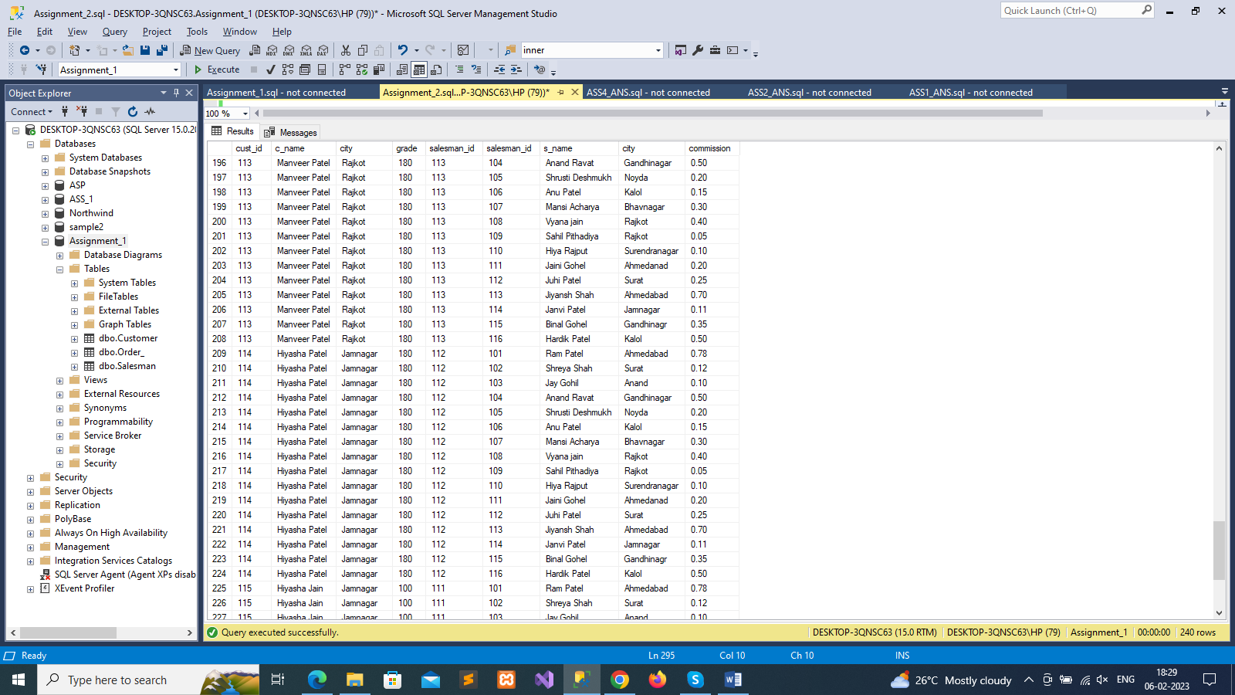

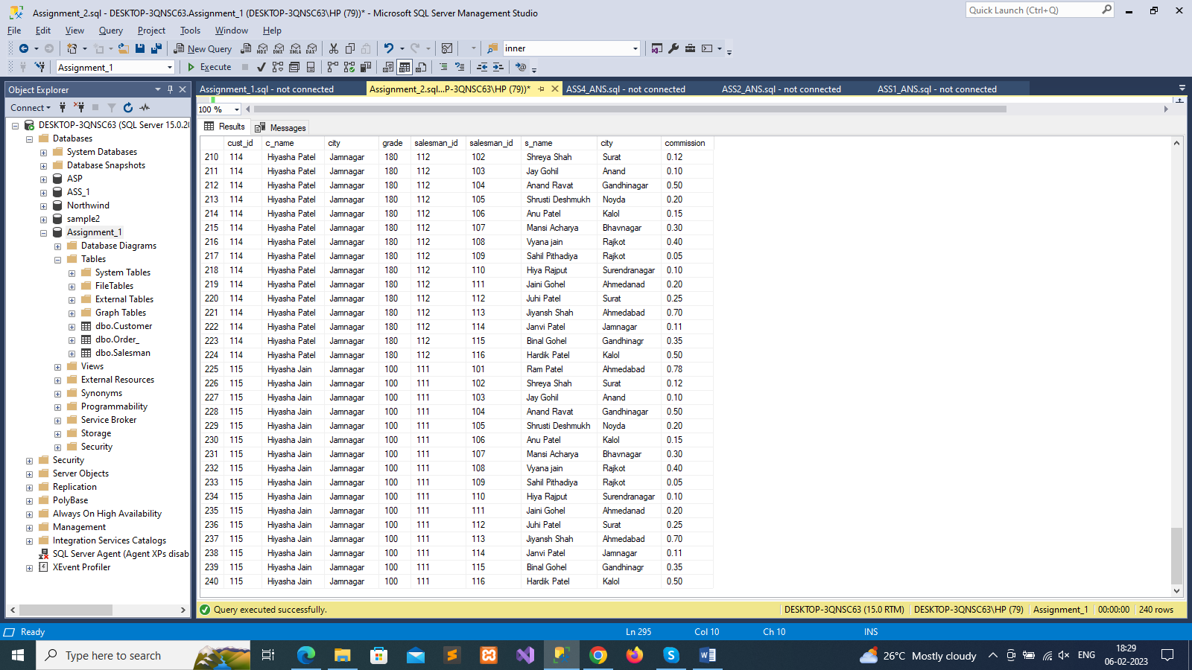

--18. Write a SQL statement to create a Cartesian product between salesperson and

--customer, i.e. each salesperson will appear for all customers and vice versa for that

--alesperson who belongs to that city

select *

from Salesman s

cross join Customer c

where s.city is not null

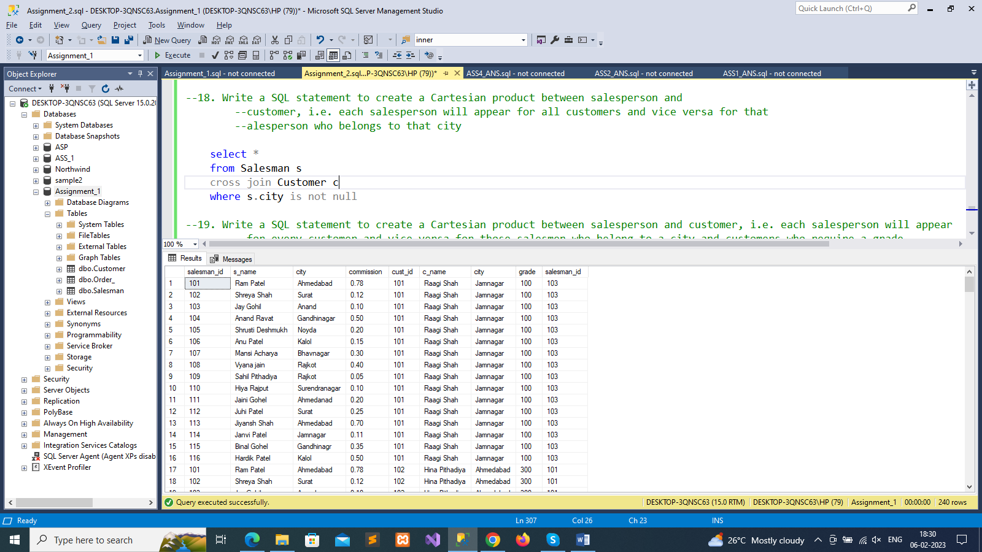

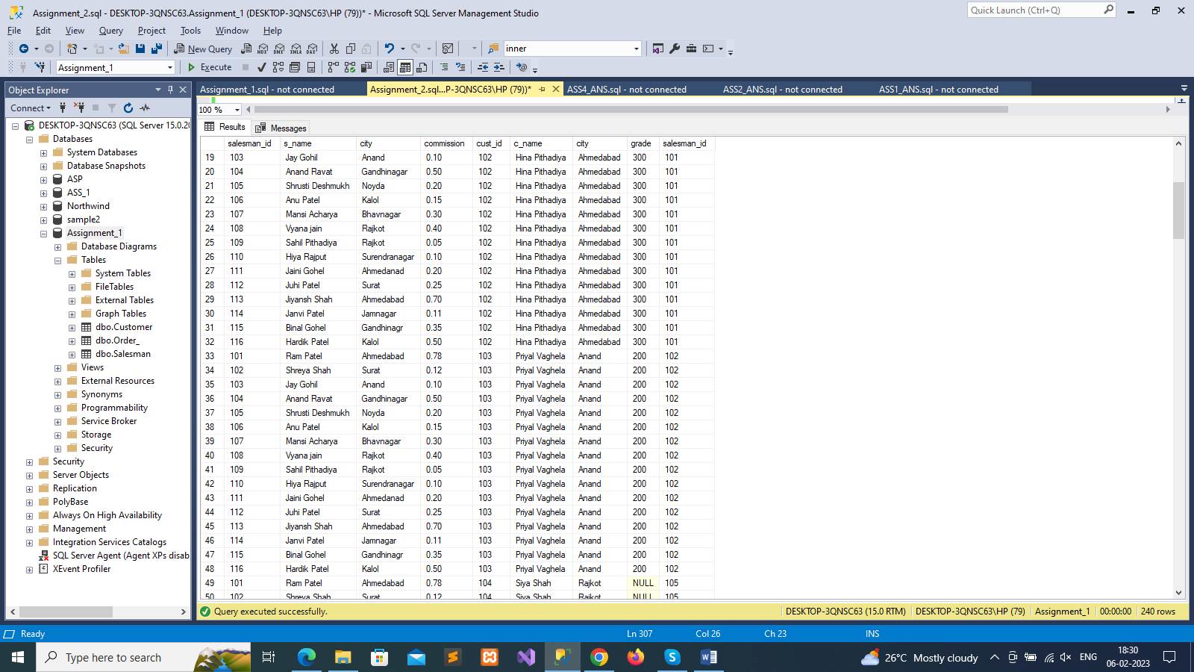

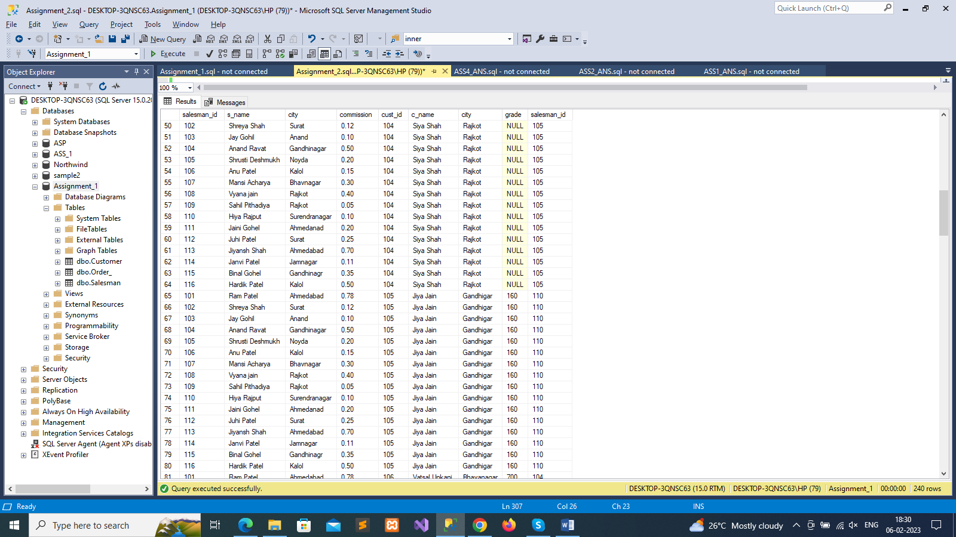

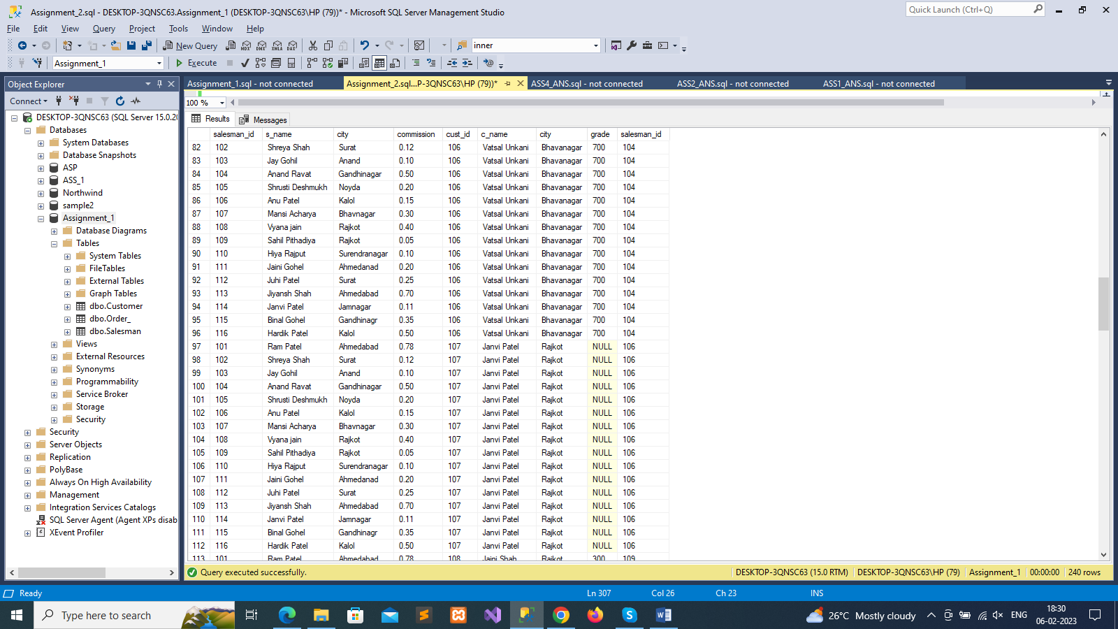

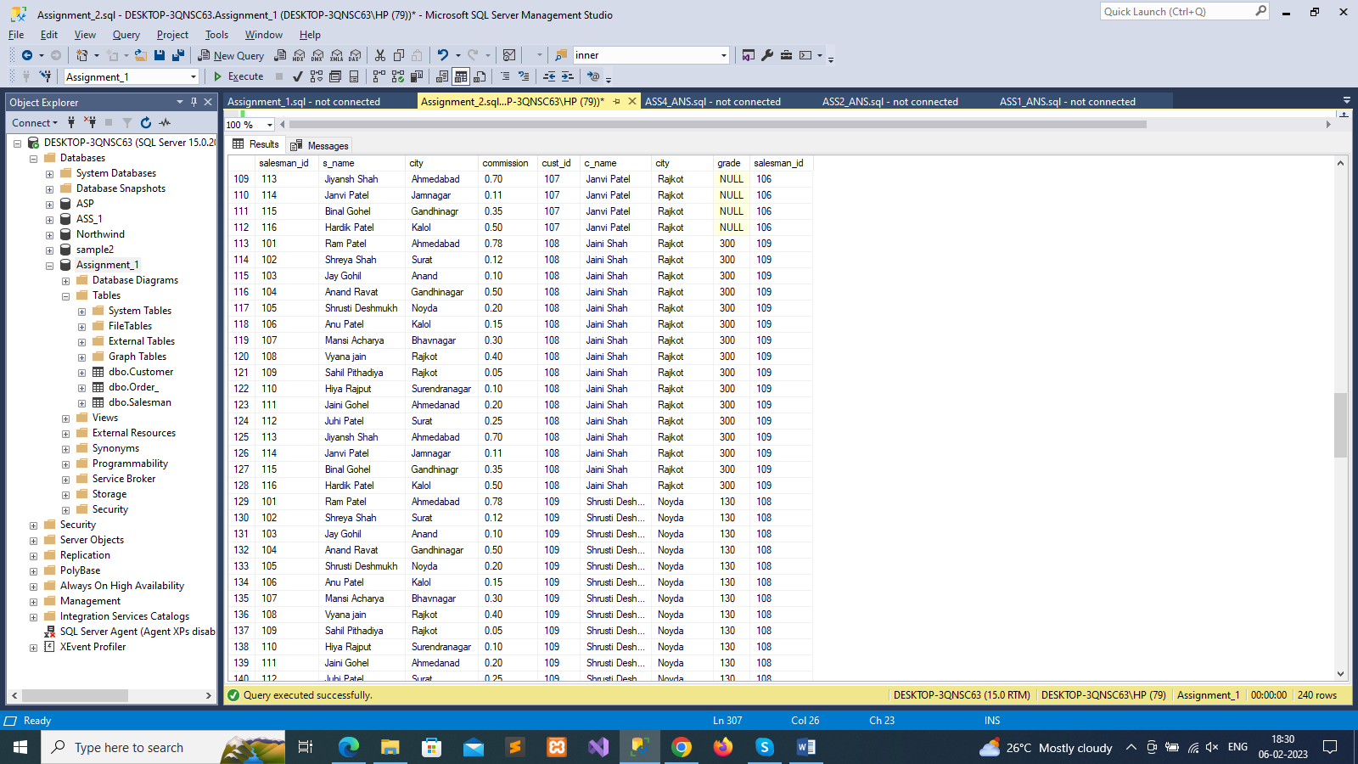

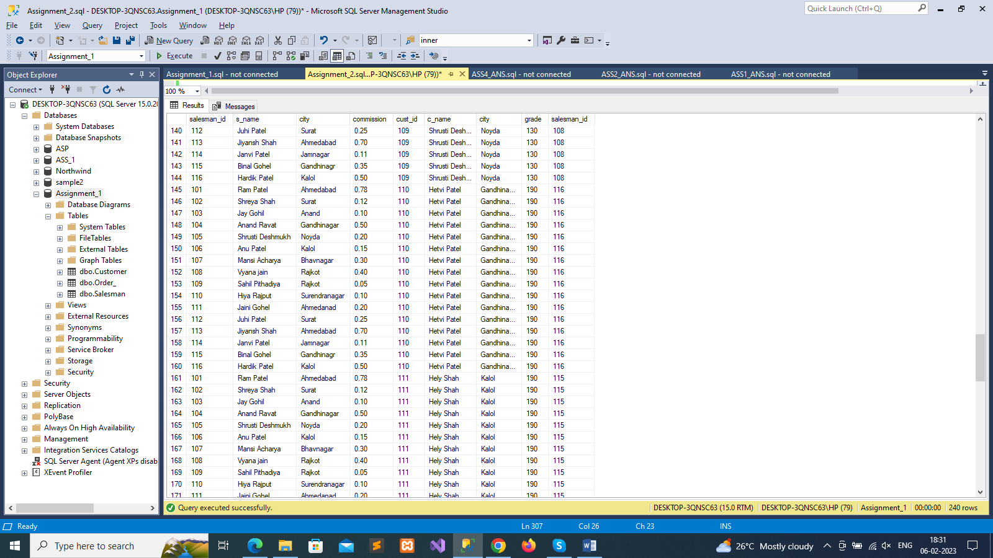

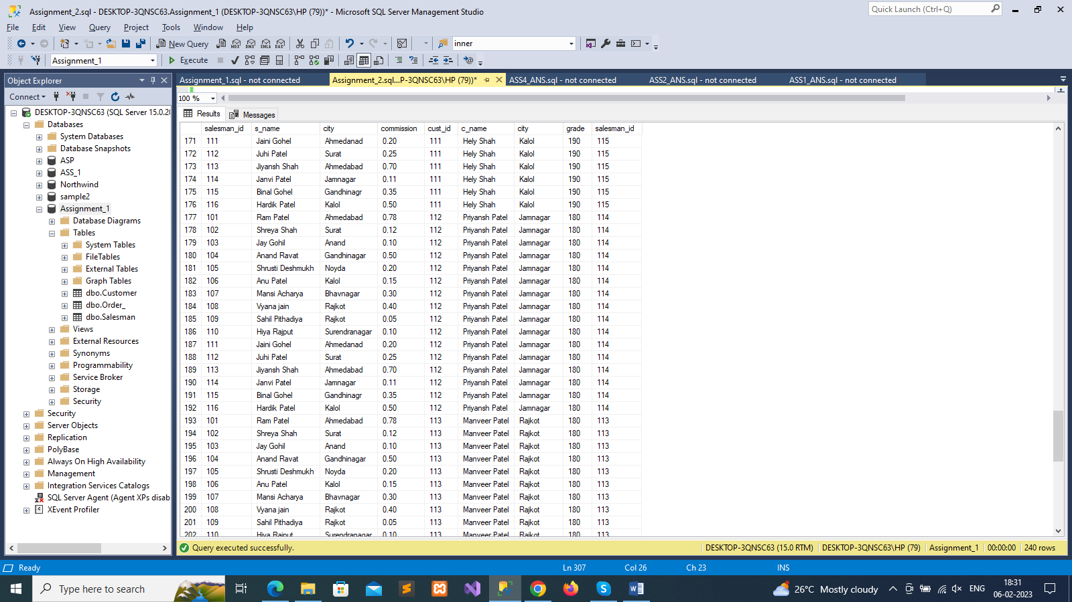

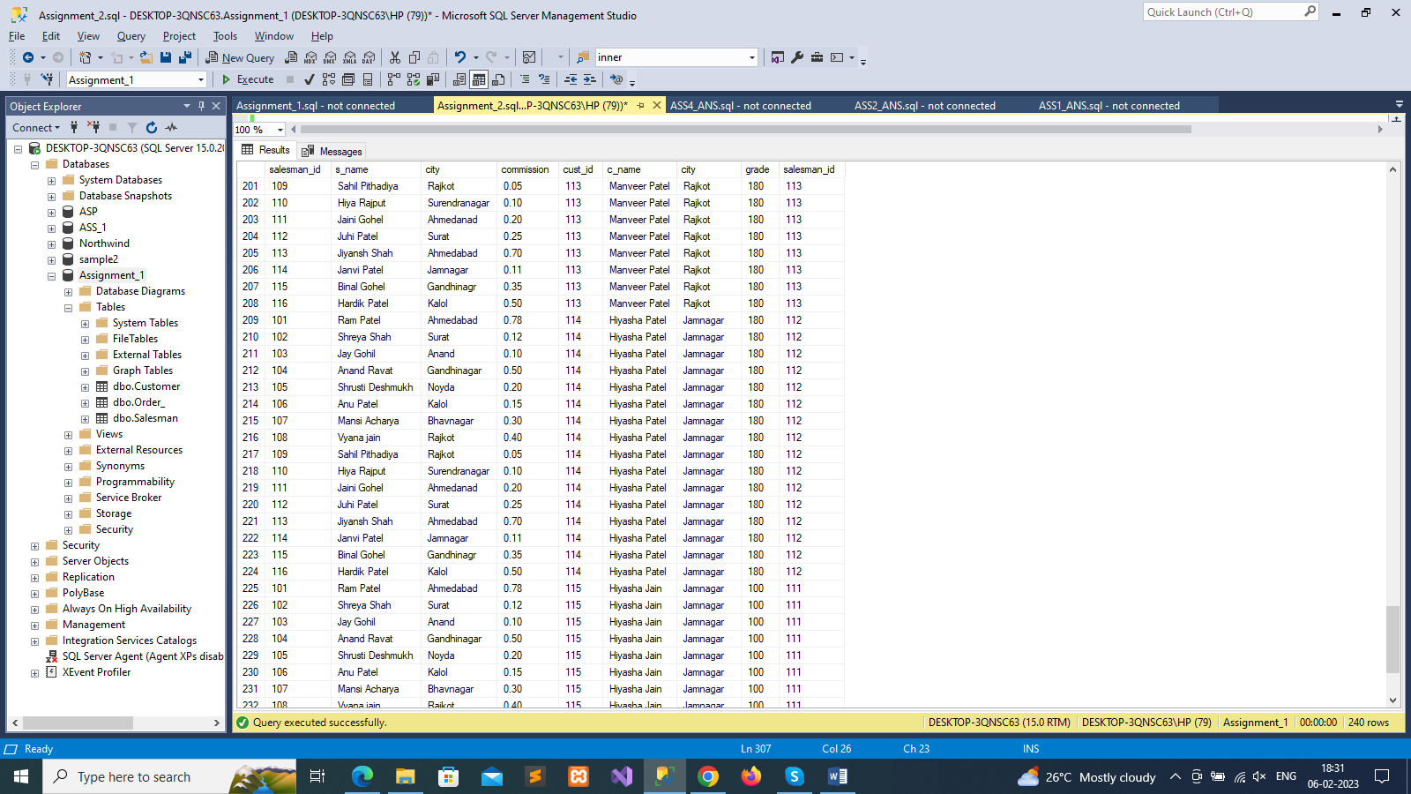

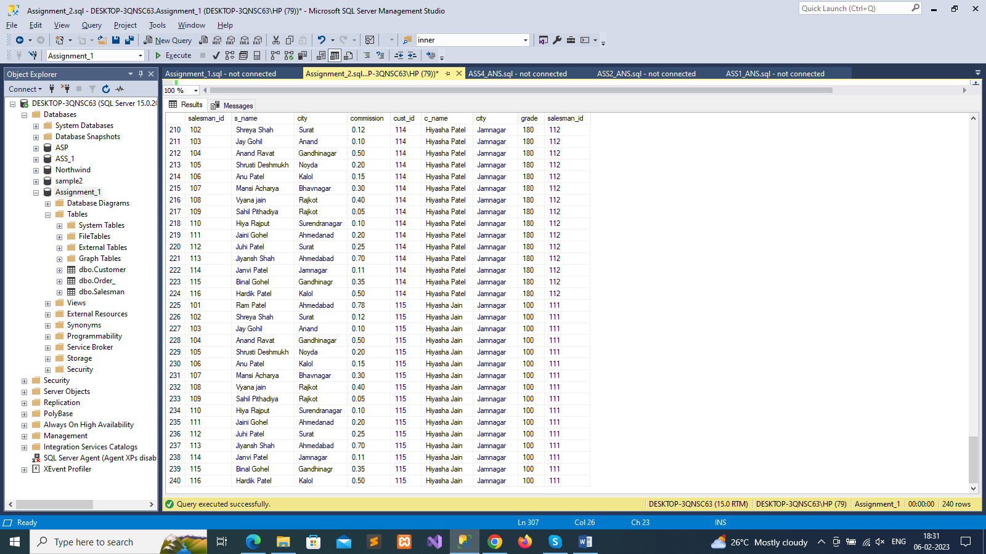

--19. Write a SQL statement to create a Cartesian product between salesperson and customer, i.e. each salesperson will appear

--for every customer and vice versa for those salesmen who belong to a city and customers who require a grade

select *

from Salesman s

cross join Customer c

where s.city is not null

and c.grade is not null

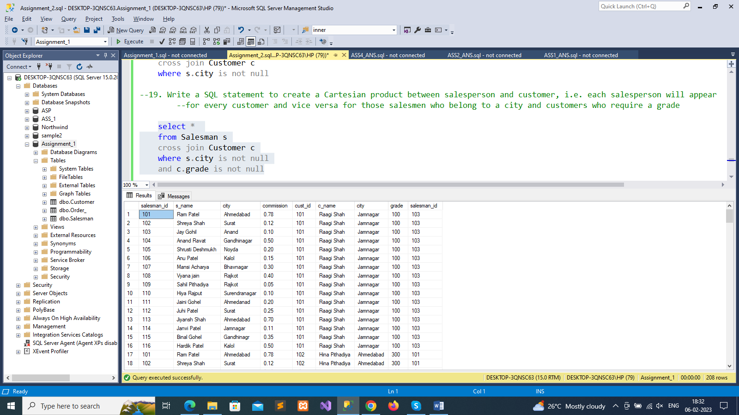

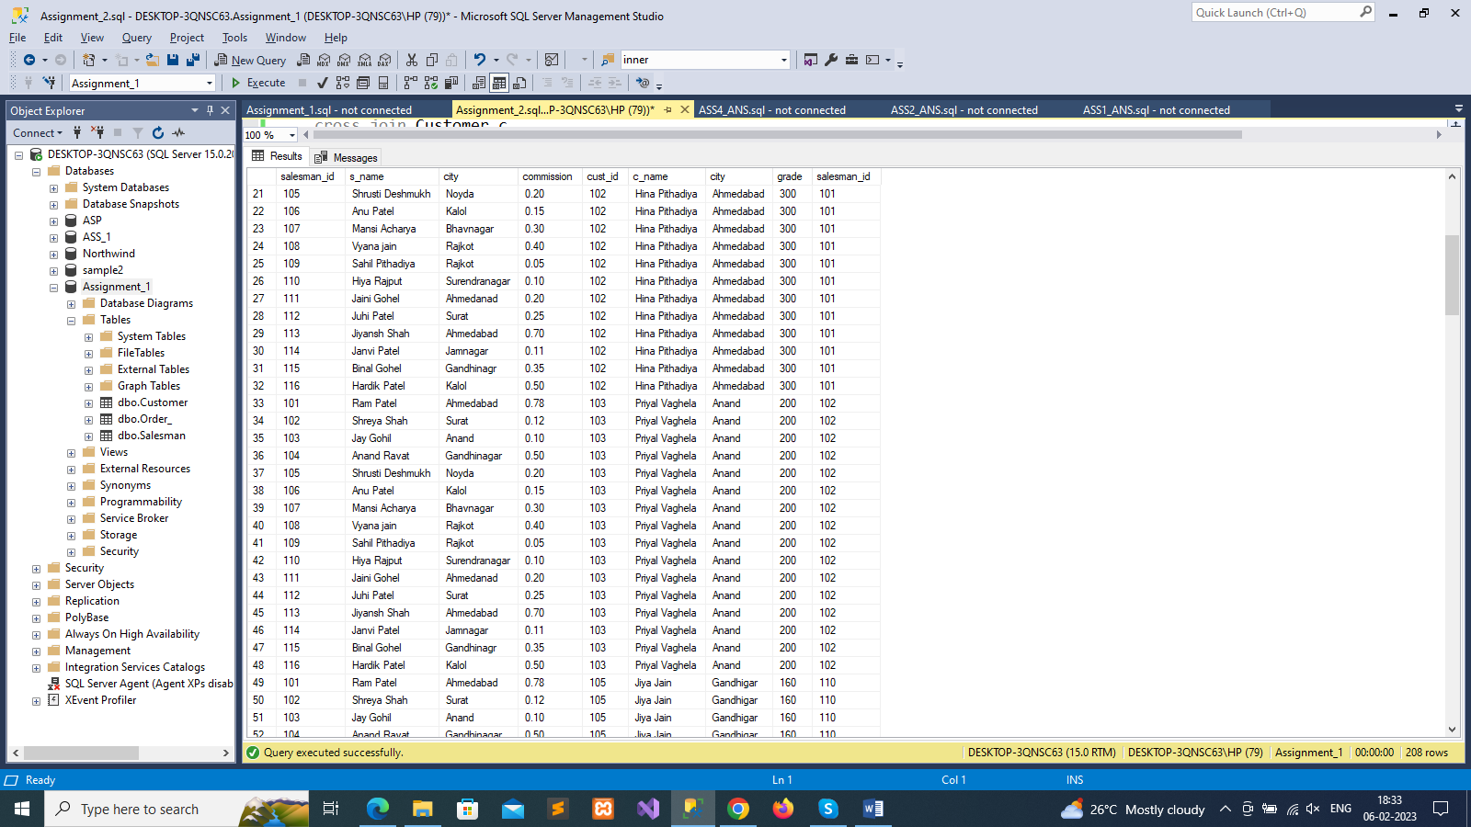

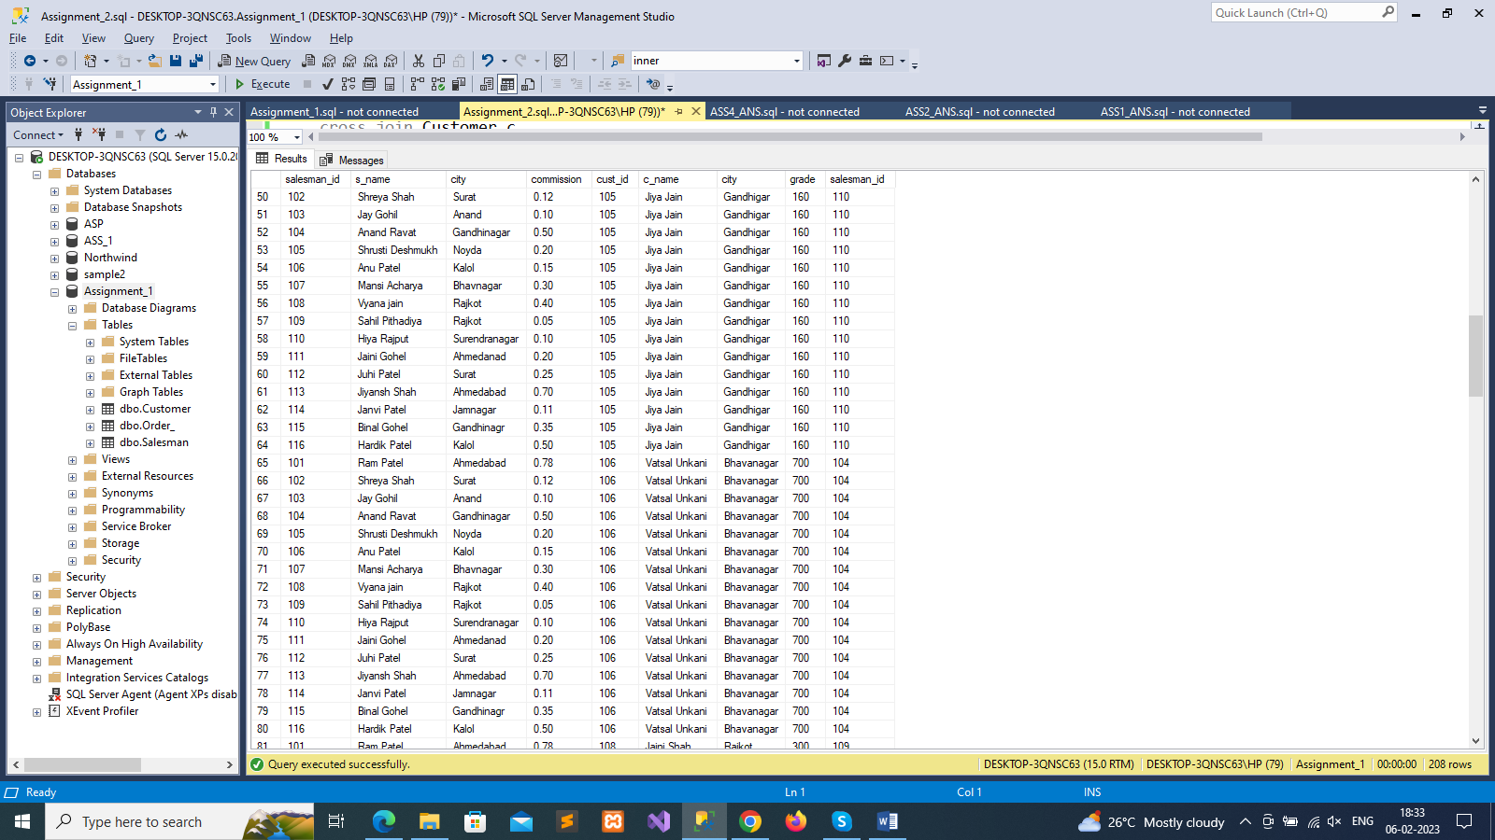

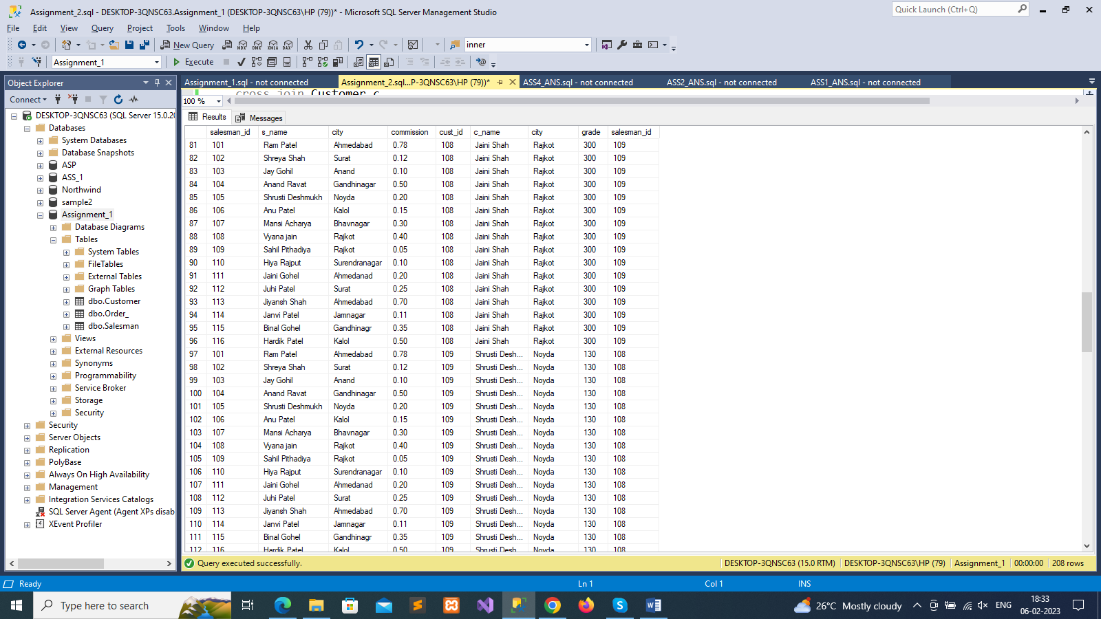

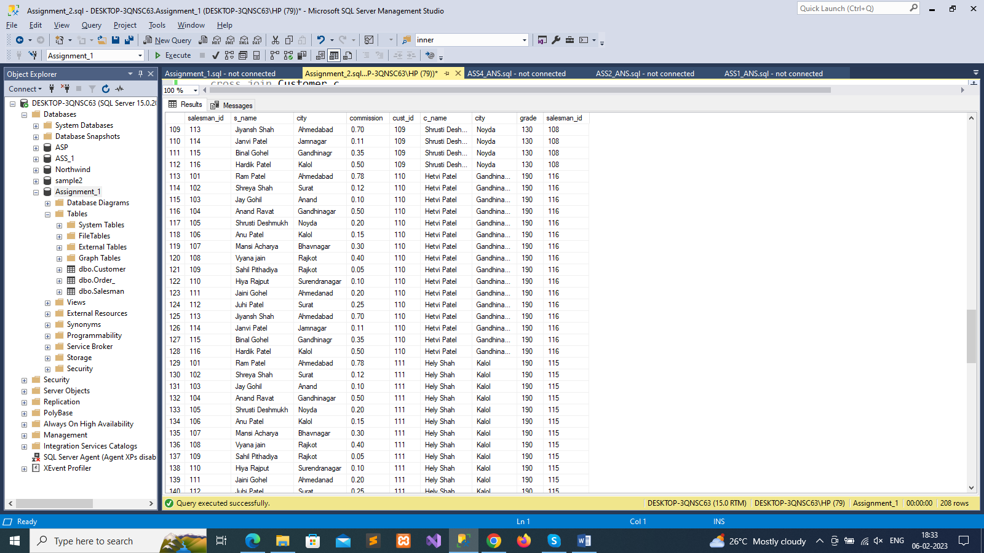

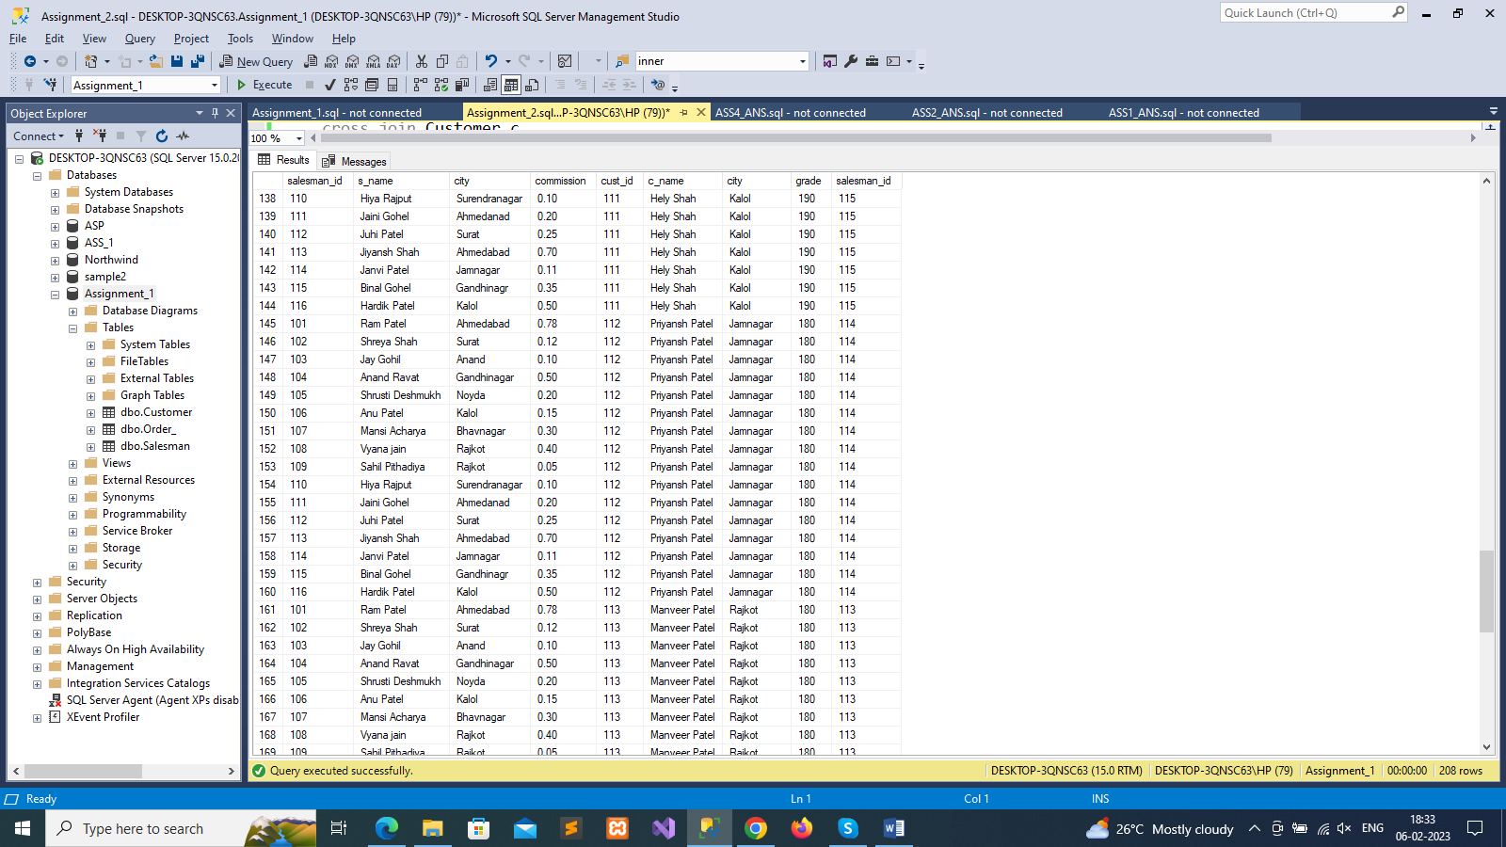

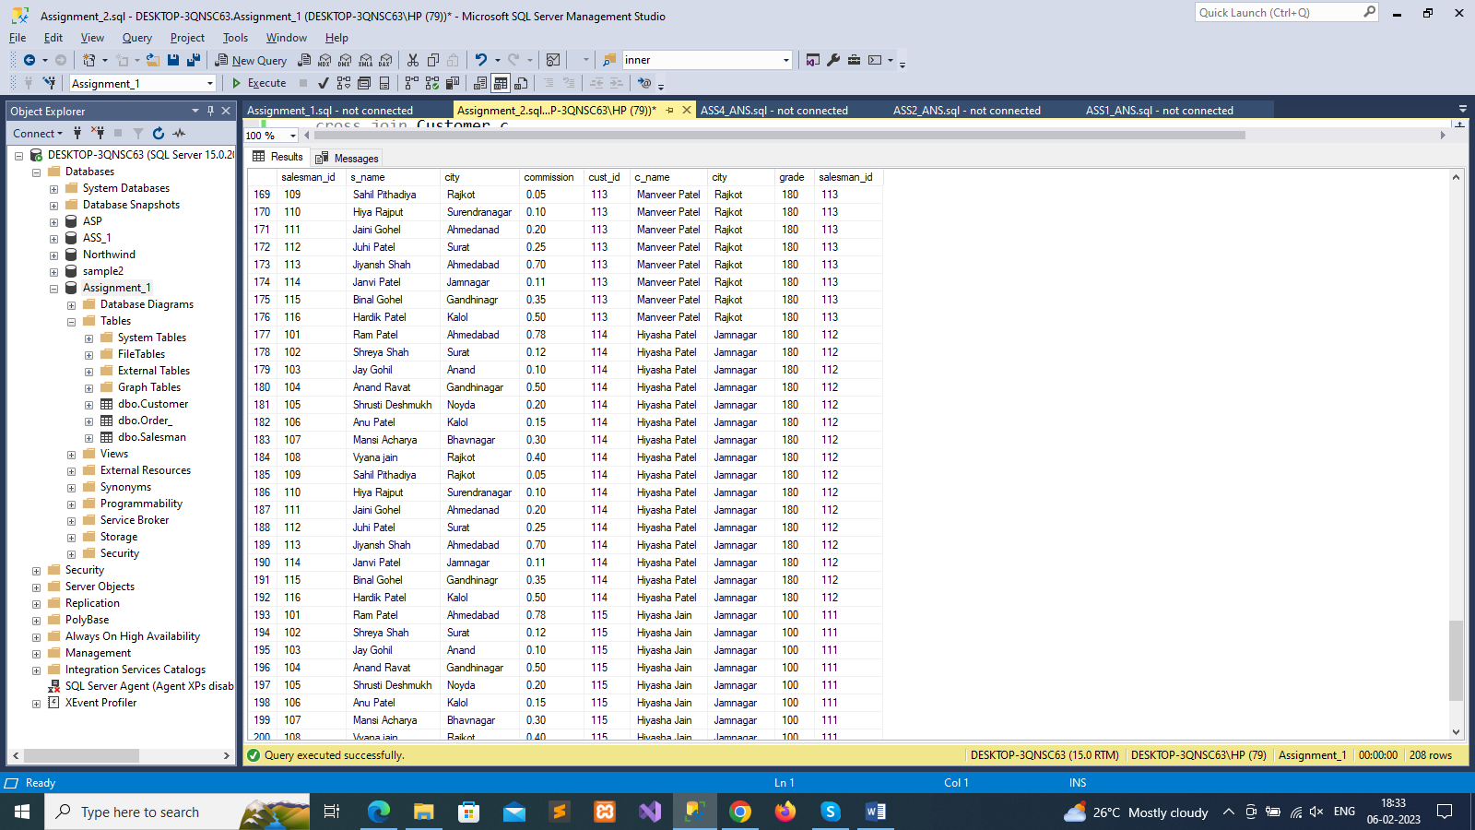

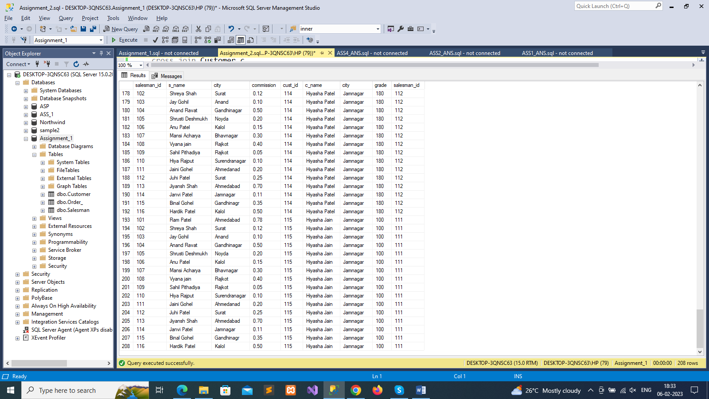

--20. Write a SQL statement to make a Cartesian product between salesman and customer i.e. each salesman will appear for all

--customers and vice versa for those salesmen who must belong to a city which is not the same as his customer and the

--customers should have their own grade

select *

from Salesman s

cross join Customer c

where s.city is not null

and c.grade is not null

and s.city<>c.city

